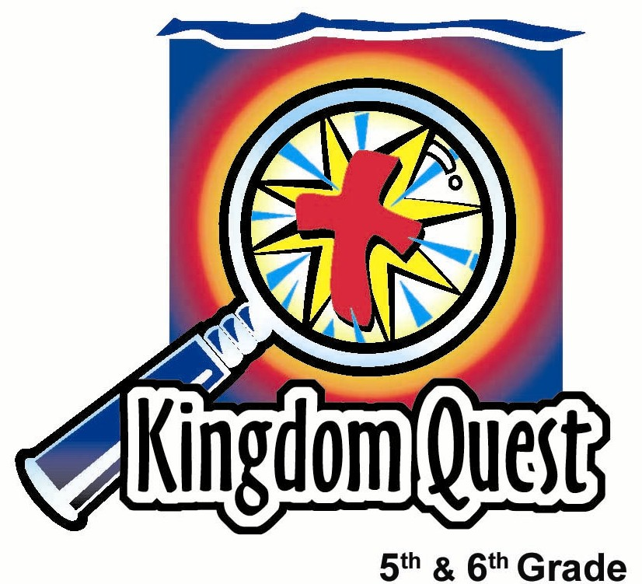
Date: _________________________
Series: Seeing God Through Suffering (Jun-Aug)
Year 2, Lesson 10
Asking the Big Question:
“Why?”

Take Home Point: *When suffering, ask “Who?” not “Why?” *Repeat this phrase throughout the lesson.

Bible Event: Job 38:1-11, 42:1-6 Job asks the question, “Why?”
Key Verses: Isaiah 55:8-9, “The LORD says, "My thoughts are not like your thoughts. Your ways are not like My ways. Just as the heavens are higher than the earth, so are My ways higher than your ways and My thoughts higher than your thoughts.”

We will help kids know:
- Highlights from Job’s encounter with suffering.
- Suffering is the result of a fallen world. God permits Satan to attack our lives and suffering to occur.
- God provides an ultimate answer: His grace given to us through His Son, Jesus.
- We ask the question, “Why?” We need to ask the question, “Who?”

We will help kids feel:
- Comforted in knowing that they will face suffering, but God will be with them through suffering.
- Curiosity to answer the question of “why?” when it comes to suffering.

We will help kids do:
- Play a game called, “Why, Why?” that exposes the folly of continually asking the question, “Why?”
- Examine an occasion for when they asked, “Why?”
- Examine the Bible for answers to the question, “Who?”
- Make a bookmark as a reminder not to get hung up on the question, “Why?”

THIS LESSON’S ROADMAP

DESTINATION | PAGE # | DISCOVERIES ON YOUR JOURNEY | SUPPLIES NEEDED
Small Group Warm-Up   | 3 | Kids play, “Why, Why?” and think of a question they have wanted to ask God that begins with, “Why?” | - a cutout letter “Y” (see appendix)
Large Group   | 4  9  10  13 | Overview  Brief Drama Sketch: This attention grabber is a two-person sketch that takes a few minutes to practice and then is ad-libbed.  Interactive Storytelling: The story of Job, especially keying on Job 38:1-11, 42:1-6, is presented with characters from the audience taking parts.  Object Lesson: The presenter folds a cut-out letter “Y” into a “U” to explain how *when suffering, we should ask “Who?” not “Why?” The answer: “You, God, are the answer to “Who?” | - script cards for the characters to read when prompted (see appendix)  - a plastic sword  - a bowl of crushed charcoal (or dirt) for ashes  - flour paste for sores  - rock or broken pottery burlap for shawl covering  - a cutout letter “Y”
Small Group Application   | 5 | Kids make a bookmark as a reminder not to get hung up on the question, “Why?”  Memory Verse Learning:  “What’s In the Box?”  Romans 8:28 will be repeated for lessons 10 – 14 to reinforce the truth that no matter what happen God always work things out for our good. | - pattern of the “Y/U” bookmark for each student (see appendix)  - scissors  - pens or pencils  - two boxes  - twelve objects
Small Group Warm-Up: 15 minutes

Purpose: Get pointed in the right direction! Build relationships and help guests feel at ease. Do the learning readiness activity that will point your group in the right direction for the lesson.


As kids gather: Listen to memory verses from last week and give coupons for memory verses, remembering to bring your Bible, and bringing a guest.

Supplies needed: a cutout letter “Y”

Explain to the kids you will play the game “Why, Why?” In other words, why ask the question, “Why?” Have kids take turns telling the group where they went for their school holidays or something special they did this holiday. While one person is telling about their experience and why it was fun for them, encourage the others in the group to fire back the question, “Why?” to every comment made. Each time a person asks “why?” the cutout letter “Y” is passed to him/her and the group tries to pass the letter all the way around the circle. The goal is to see which student can give answers to all the “Whys” asked by other members of the group.

Option: If kids don’t want to talk about something special they did during the holidays, they can talk about what they are looking forward to when school reopens.

After the kids have had some fun, ask:

Think of one thing you have always wanted to ask God. Begin your question with “Why?”

Again pass the letter, “Y” as kids share a question they have always wanted to ask God.

Today we will hear how Job asked God, “Why are You letting all these bad things happen to me?” Maybe this is a question we have asked before. Certainly it will be a question all of us will ask at sometime in our life.

We will learn today *when suffering, ask “Who?” not “Why?”
Large Group: 20-30 minutes
Purpose: Help kids observe what the Bible says. Present the Bible event in creative fashion. Help kids begin to interpret what it means.

Overview

Brief Drama Sketch: “Why Cancer? Why Me?” Two teens or preteens present a two-minute sketch as an attention grabber.

Bible Event: The book of Job. More specifically, Job 38:1-11, 42:1-6.

Object Lesson: The presenter folds a cutout letter “Y” into a “U” to explain how *when suffering, we should ask “Who?” not “Why?” The answer: “You, God, are the answer to “Who?”

Small Group Application: 20-25 minutes
Purpose: Help kids map out the meaning of the Bible event in their lives. Use the questions to stimulate discussion, but don't feel tied to them. Allow the Holy Spirit to guide you. Include personal examples from your own faith journey. The example of Christ at work in your life will leave lasting impressions of how Christ can work in the children's lives.

Use your Bibles! Children need to learn how to look up references and follow along when scripture is read aloud. Allow for quality time of prayer at the close of the lesson.

Observation Questions: What happened?
Read Job 38:2-3.
Did God answer Job’s question, “Why?”(No. God responded by asking Job questions.)

Have kids skim through the rest of Job 38.
How many times did God ask Job, “Who?” (Eleven times in GW translation.)

God’s questions revealed that God was more magnificent than Job could ever comprehend. Our key verse for today from Isaiah 55:8-9 says, “The LORD says, "My thoughts are not like your thoughts. Your ways are not like My ways. Just as the heavens are higher than the earth, so are My ways higher than your ways and My thoughts higher than your thoughts.”

Read Job 40:3.
How did Job respond when God finally spoke to him? (He was humble.)

What did Job do in Job 42:2&6? (He repented.)

What did God do for Job after he repented? (Job 42:10-17. God restored Job’s wealth, gave him more family and allowed Job to live to a very old age.)

Interpretation Questions: What does this mean?
Do you think God took away Job’s wealth, health and family? (No. Job 1:6-12 and Job 2:1-6. God gave permission to Satan to strike Job to show how faithful Job was.)

Does it sometimes seem incomprehensible that God loves us so much that He sent His Son, Jesus, to die in our place?

We might never be able to fully understand this, but that is how Jesus becomes the answer to “Who?”

Application Questions: What does this mean to me?
Supplies needed: patterns of the “Y/U” bookmark for each student, scissors, pens or pencils

How should we talk to God when we are suffering? (It is appropriate to express to God how we feel and that we don’t understand, but we should not demand that God respond a certain way. Instead we can ask Him to teach us that loving Him is more important than having all of our questions answered.)

Think about a time something happened to you that made you ask, “Why, God?”

Encourage kids to share their stories and then ask,

Did God give you the answer?

What can we learn from Job? (God may not answer why, but He will answer the question “Who?”)

Pass supplies out to the kids and explain that they will make a bookmark to answer the question, “Who?” Show them an example of the paper fold bookmark and say:
The following paper fold is a great Bible bookmark that reminds us to change our “Why?” into “Who?”

Fold the “Y” into a “U.”



We can say, “You, God, are the One in charge.”
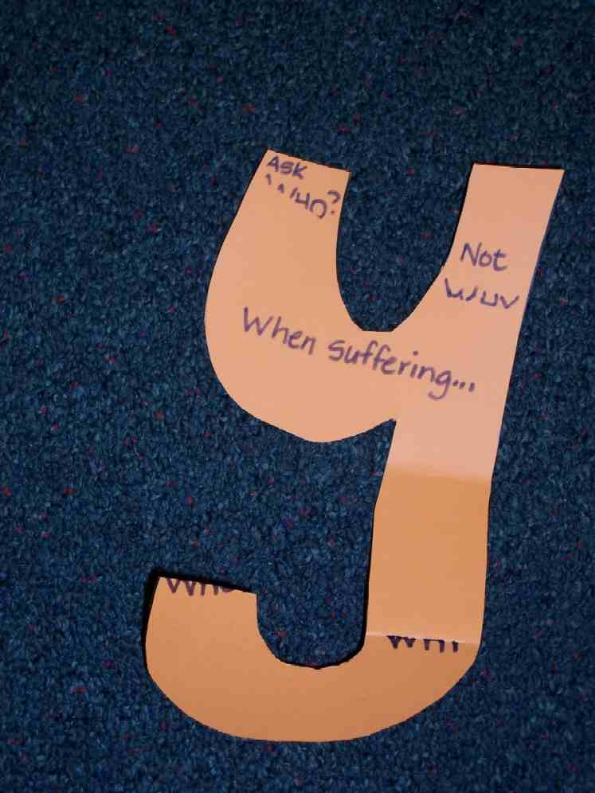
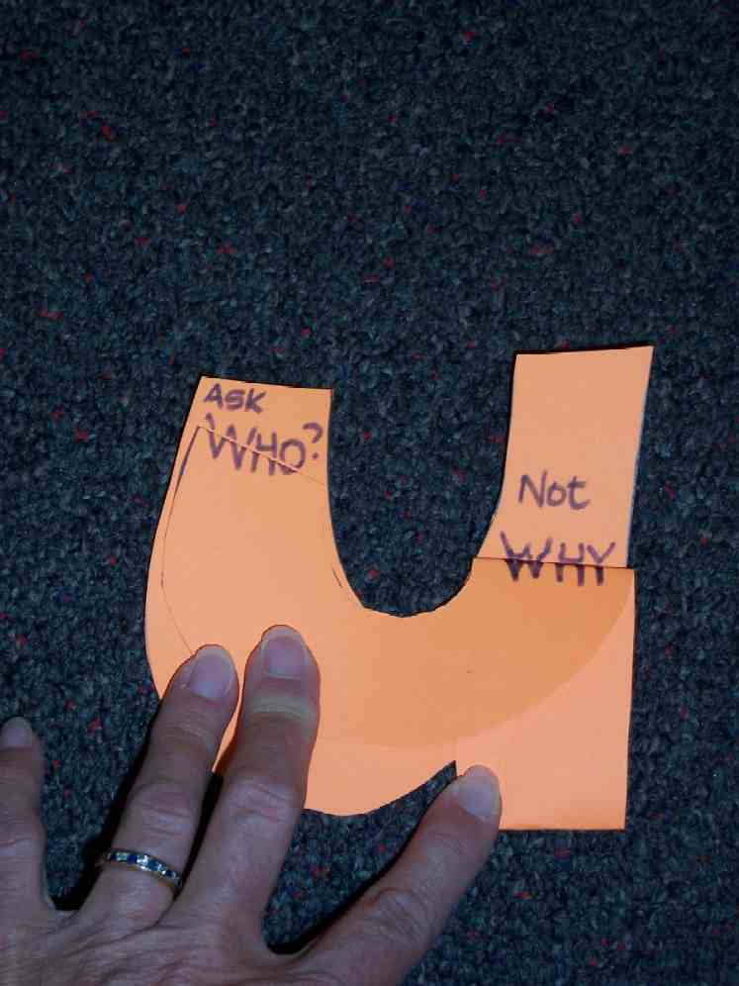

When kids have cut out the bookmark, have them fold the “Y” into a “U.” Have them copy the key verse onto the bookmark while folded in a “U” so that it doesn’t make sense when opened up as a “Y.” Discuss what the kids think the passage means.

Then say:

We won’t get all the answers when we ask, “Why?” but when we look to You, God, we do. You are the answer to all our questions. You are the One who loves us the most. In You we can place our trust even when we don’t understand.

Today, we learned that *when suffering, ask “Who?” not “Why?”

What is the answer to the question, “Who?” …You, God!

Optional or additional reading: Romans 11:33-36. If using this passage, you could instead have kids write on their bookmarks: “Who knows how the Lord thinks?… Everything is from Him and by Him and for Him.”

Memory Verse Learning: 5 minutes
Purpose: Help kids to memorize and keep scriptures at heart. Using creative ways to help kids enjoy learning the key verse and in small group setting.

Supplies needed: two boxes with a hole cut in one of the side, twelve objects

Memory Verse: Romans 8:28 ~ “We know that in everything God works for the good of those who love Him. They are the people He called, because that was His plan.” (NCV)

MV Presentation: “What’s in the Box?”
Before class, place six objects in each box. Begin the game by reciting the memory verse together with the children. Repeat the process once or twice. Then divide the children into two teams, A & B. Ask the first child of each team to put their hand inside, feel an item and say what he/she thinks it is. Once he/she has named an item, the next child in the team has a go. The first team to name all six items correctly is the winner. Have each team recite the memory verse together. Try the following items: an orange, a sock, a hairbrush, a wooden spoon, a ball, a comb, a toothbrush, a keychain, a band-aid.

Prayer Time:
Ask God for the strength and endurance to trust Him in all circumstances. He is the “Who?” even when we don’t understand the “Why?”

Large Group Presentation

Why Cancer? Why Me?
Brief Drama Sketch

Purpose: Grab people’s attention and set up a felt need understood by kids. This is to be answered from God’s word.
Characters: Two teenage girls or could be girls of any age.

Plot Summary
The story has a simple plot line that can be remembered and acted out without memorizing lines. Stephanie just found out that the reason she feels tired and sick is that she may have some kind of cancer. She talks about the bad things she imagines happening to herself. Each time she asks, “Why?” She even questions: “Why, God?” Her friend Joo Ann doesn’t quite know what to say. She finally concludes with, “I don’t know why!”

Story Board
Introduction
The large group presenter says, “I’d like to introduce Joo Ann and Stephanie. Joo Ann has just come over to Stephanie’s house for a visit.”

Greetings and “What’s wrong?”
Joo Ann and Stephanie meet. But Joo Ann notices that Stephanie looks sad and depressed. Stephanie doesn’t know quite how to talk about it, but finally tells what’s bothering her. She just got back from the doctor and they think that the stomachache she’s been having has something to do with cancer.

“Sick all the time”
Stephanie talks about her fear of being sick all the time. She hates pills and hospitals and feeling lousy. She asks, “Why did this happen to me? Did I do something wrong?” Joo Ann says, “It couldn’t be that”

“Hair will fall out”
Stephanie talks about her fear of hair falling out. She asks, “Did God make this happen to me because He hates me?” Joo Ann says, “It couldn’t be that.”

“No friends”
Stephanie talks about her fear of not going out with her friends. “Doesn’t God care?” she asks. Joo Ann assures her that God still cares.

“Short life”
Stephanie talks about fear of not being able to grow up and do all the things she wanted… Joo Ann tells her not to talk that way.

“Why, God?”
Stephanie finally says it’s not fair! She says, “Why, God? Why, me?” Joo Ann says, “I don’t know why.” It ends right at that point.

Interactive Storytelling

Supplies: script cards for the characters to read when prompted (see appendix), a plastic sword, a bowl of crushed charcoal (or dirt )for ashes, flour paste for sores, rock or broken pottery, burlap for shawl covering, a cutout letter “Y”

Presenter:

Welcome, kids. Today we begin four weeks of topics that deal with suffering. I know this is not a very pleasant topic, but suffering is something we all encounter. When we go through suffering, God really can get our attention. Let’s learn these next four weeks how we can see God even when we go through suffering.

When tragedy hits, what is usually the first question we ask? “Why? Why is this happening to me? Why are you allowing this, God? Why, God?”

I would like to introduce you to a man in the Bible who was an expert in suffering: Job. I wonder what he learned about asking the question, “Why?”

The following Bible event is about God’s servant Job, and is found in the book named after him.

Select six volunteers to act as four servants, Job’s wife and Job. Position Job on one side of the stage, the servants and the wife on the other. Prompt the audience to say, “Why?” anytime the letter “Y” is held up. Then begin.

Job was a decent man that feared God. He stayed away from evil. He was very rich with seven thousand sheep, three thousand camels, a thousand oxen and five hundred donkeys. He also had a large number of servants. Job was one of the richest men in all the Middle East. He had seven sons and three daughters. He had it all. But he also loved God deeply, and he regularly gave sacrifices to God.

Now imagine a scene in heaven: Satan, a fallen angel, who is also the accuser, came before God. He said, “I have wandered all over the earth noticing people.”

The Lord asked Satan, “Have you noticed My servant, Job? He fears God and stays away from evil. ”

Satan answered the Lord, “It is because You have put a protective fence around him and blessed everything that he does. But if You were to take it away, I bet he will curse You right to Your face.”

Then the Lord told Satan, “I give you permission to take away what he has. But you must not hurt him.”

Then Satan left the Lord’s presence.

So in one day, complete tragedy hit Job. His first servant arrived with this message.

Terrible news
Prompt one of the servants to enters with a sword and read his script card.

Servant: Terrible news. Raiders attacked us. They stole all your oxen and your donkeys. They killed all your servants. I alone escaped to tell you this bad news.

Prompt next servant to read his lines:
Bad news. Lighting came from heaven and completely destroyed your flocks and servants. I alone escaped to tell you.

Presenter:
While he was still speaking, the next servant came.

Prompt the next servant to read:
The Babylonians attacked and stole the camels. They killed all the servants. I alone escaped to tell you.

Presenter:
While he was still speaking, another servant came.

Prompt last servant to read:
A wind blew down your house where all your children were feasting. They were all killed. I alone escaped to tell you.

Presenter:
Job was so sad, he tore his clothes in grief and shaved his head. But still he did not sin.

Prompt Job to read his lines:
Naked I came from my mother, and naked I will return. The Lord has given and the Lord has taken away. May the name of the Lord be praised.

Again Satan appeared before God. God asked him, “Have you thought about My servant, Job? He still fears Me and stays away from evil.”

But Satan said, “Any man will give everything he has for his life, but if You stretch out Your hand and strike his flesh and hurt his body, I bet he will curse You to Your face.”

The Lord told Satan, “He is in your power but you must spare his life.”

So Satan left the Lord’s presence and struck Job with painful boils all over his body.

Adhere some flour paste to Job.

Job was in so much pain and misery that he sat in ashes.

Put ashes on his face and give him the broken pottery. Place the shawl around him.

He took a broken piece of pottery to scratch his sores. He sat in sackcloth to show his sorrow.

Then his wife came to him and said,

Prompt Job’s wife to read:
My advice to you is to curse God and die.

Presenter:
But Job did not take this advice. Instead he did not say one sinful word. Then Job had three friends who visited him.

Prompt three of the servants to act out the following:

They saw how sad he was and in such great pain. When they saw him, they cried out loud and tore their own clothes in grief. Then they sat with him for seven days and seven nights. This was the way they showed empathy for his problem. It was the best thing they did. They made a mistake when they gave him advice.

The first one said (hold up the letter, “Y”), “Why would God do this to you? Only evil people suffer. You must have done evil.”

The second one said, “God does not punish an innocent person. You must have done something.”

But Job did not agree. He promised he had done no wrong.

The third friend said, “Confess your sins and God will lift this punishment from you.” But Job disagreed that his tragedy was because he was being punished. He insisted that he had done nothing wrong to deserve this.

Everyone was asking the question (hold up the letter, “Y”), “Why?” Why, God, would You let this happen to someone who loves and trusts You?

Intermission break.
Ask audience:
Object Lesson

Why do you think God would allow Job to go through so much suffering?

Take answers from the audience. Accept input and then continue with the Bible event.

Job found out that God never did give him an answer to the question, “Why?” Instead, God asked Job a question. The question is not, “Why?” (Hold up the letter, “Y.”) The question is, “Who?” Who is in charge? Who is the One who loves us more than anyone else? Who is the One who holds our future in His hands? Who is the one who can be trusted with our lives?

When we ask that question of God, this is the answer…

Make the letter “Y” become a “U.”

The answer is you. Sometimes we will never know the answer to “Why?” but we can always know the answer to the even better question, “Who?”

God said this after Job asked him “Why?” Job 38:2, “Who is this that belittles My advice with words that do not show any knowledge about it?”

Conclusion to Bible Event
Job then repented. In Job 42:2 & 6 he answered the Lord, “I know that You can do everything and that Your plans are unstoppable…That is why I take back what I said, and I sit in dust and ashes to show that I am sorry.”

Pretend to pour the ashes over Job’s head.

The Lord accepted Job’s apology. Job learned that he could not understand everything about God. Certain things happen that are far too great for his understanding. Even if it didn’t seem fair, he learned that he should still trust God. He learned not to try to be God’s judge, by asking the question, “Why?” Instead, he asked the question, “Who?” The answer was You. YOU are the God of the universe.

After Job had learned this, the Lord once again blessed him. He gave him more livestock than before. He even gave Job more children, seven sons and three daughters. He lived 140 more years to see his great-grandchildren.

The principle is this: When tragedy strikes us, we sometimes ask the question, “Why?” God may choose not to answer that question, but we can always know the answer to the question, “Who?” The answer is YOU. You, God, are in control.

Again make the letter “Y” become a “U.”

Our God loved us so much that He gave us His own Son, Jesus. As we remember that, we have power to see that God is still with us even through our suffering.

The Bible says in Isaiah 55:8-9, , “The LORD says, "My thoughts are not like your thoughts. Your ways are not like My ways. Just as the heavens are higher than the earth, so are My ways higher than your ways and My thoughts higher than your thoughts.”

Closing prayer
Thank God for this testimony and give glory for how God was revealed. Thank Him for the assurance that we can always trust that God is who He says He is.

Lesson 10
Small Group Warm-Up

- a cutout letter “Y” (see appendix)

Large Group
- script cards for the characters to read when prompted (see appendix)
- a plastic sword
- a bowl of crushed charcoal (or dirt) for ashes
- flour paste for sores
- rock or broken pottery burlap for shawl covering
- a cutout letter “Y”

Small Group Application
- pattern of the “Y/U” bookmark for each student (see appendix)
- scissors
- pens or pencils

Memory Verse Learning
- two boxes with a hole cut on one of the side whereby a hand can fit in
- twelve objects

Servant #1:
Terrible news. Raiders attacked us. They stole all your oxen and your donkeys. They killed all your servants. I alone escaped to tell you this bad news.

-----cut here---

Servant #2:
Bad news. Lighting came from heaven and completely destroyed your flocks and servants. I alone escaped to tell you.

Servant #3:
The Babylonians attacked and stole the camels. They killed all the servants. I alone escaped to tell you.

---cut here---

Servant #4
A wind blew down your house where all your children were feasting. They were all killed. I alone escaped to tell you.

Job:
Naked I came from my mother, and naked I will return. The Lord has given and the Lord has taken away. May the name of the Lord be praised.

---cut here---

Job’s wife :
My advice to you is to curse God and die.


