
Date: _________________________
Series: Seeing God Through Suffering (Jun-Aug)
Year 2, Lesson 12
Jesus… Suffering the Cross For Our Good
Take Home Point: *God can turn bad things into good.
*Repeat this phrase throughout the lesson.

Bible Event: Matthew 27:31-50; Genesis 50:20
Key Verse: Genesis 50:20, “You meant to hurt me, but God turned your evil into good to save the lives of many people, which is being done. (Though said by Joseph, this reflects the truth throughout scripture, especially in the life of Jesus.)

We will help kids know:
- Bad things happen in our world, including death. God sometimes allows these things to happen.
- God can make good things happen out of bad. Jesus’ death outwardly seemed like a bad thing, but through it, death became a doorway for us to enter heaven to experience a perfect relationship with God.

We will help kids feel:
- Awed by the power of God’s love that He gives them in Jesus.
- Hopeful knowing that, even in bad circumstances, God’s good can ultimately triumph through faith in Christ.

We will help kids do:
- Wrestle with and discuss some deep questions as they ask why God lets bad things happen to people.
- Examine God’s word for the truth of His victory for us in Jesus.
- Craft a needlepoint cross as a visual reminder of how God can turn bad things into good.
THIS LESSON’S ROADMAP

DESTINATION | PAGE # | DISCOVERIES ON YOUR JOURNEY | SUPPLIES NEEDED
Small Group Warm-Up   | 3 | Students recall their feelings when seeing a traffic accident or natural disaster and discuss why God could let bad things happen. | - pieces of yarn in a variety of colors (Use in application craft.)
Large Group   | 4  7  10  10 | Overview  Brief Drama Sketch: Two teenagers talk about a friend killed in a car accident and what good could possibly come of it.  Video Presentation: The Visual Bible: Matthew 27:31-50. This clip shows the crucifixion of Jesus, especially when he felt forsaken by God.  Object lesson: While discussing Jesus’ death and what good came of it, the presenter weaves the shape of a cross. The students only see the messy side until it is turned around to reveal the planned and good side. | - two-foot square masonry metal or plastic grid with holes smaller than chicken wire, but large enough so that thick yarn can easily be woven through by hand making the design of a cross  - thick yarn  - Bible  - video, The Visual Bible: Matthew 27:31-50, produced by Visual Bible International, 1997
Small Group Application   | 5 | Students relate how Jesus’ suffering on the cross was for our good while stitching a cross as a reminder that what looks bad on one side to us, has a heavenly design on the other.  Memory Verse Learning:  “Who’s Got the Ball”  Romans 8:28 will be repeated for lessons 10 – 14 to reinforce the truth that no matter what happen God always work things out for our good. | - plastic or fabric cross-stitch canvas in a cross shape, one cross per student  - needles  - yarn  - small rubberball
Small Group Warm-Up: 15 minutes
Purpose: Get pointed in the right direction! Build relationships and help guests feel at ease. Do the learning readiness activity that will point your group in the right direction for the lesson.

As kids gather: Listen to memory verses from last week and give coupons for memory verses, remembering to bring your Bible, and bringing a guest.

Supplies: pieces of yarn in a variety of colors (will be used later in the craft)

Wad the yarn into a big ball and place it in the center of the group. Discuss the following:

Tell about a time when you saw a traffic accident or natural disaster, such as a fire, flood, or tornado. If you haven’t seen one in person, you might think about the image of one you saw on TV. Describe that scene. Was it a mess like this wadded up yarn?

How do you think the scene was different before that disaster?

How did you feel after you saw the disaster?

Pull out a piece of yarn. Hold it up and ask:

Did you ever ask, “Why did God let this bad thing happen?”

Hold up the whole wad of yarn pieces and add:

Or did you ever ask, “Why did God let this world get so jumbled up with disasters?”

If you have ever asked yourself this question or think you might have an answer, take a piece of yarn from the ball as you share your thoughts with the group.

Pass the yarn ball around and have kids discuss.

Today we are continuing our series on seeing God through suffering. How can God let bad things happen? More importantly, can God turn suffering into something that is good?

We will learn today that *God can turn bad things into good.

Large Group: 20-30 minutes
Purpose: Help kids observe what the Bible says. Present the Bible event in creative fashion. Help kids begin to interpret what it means.

Overview

Brief Drama Sketch: Two teenagers talk about a friend killed in a car accident and what good could possibly come of it.

Video Presentation: The Visual Bible: Matthew 27:31-50, produced by Visual Bible International, 1997. The clip shows the crucifixion of Jesus, especially when he felt forsaken by God.

Object lesson: While discussing Jesus’ death and what good came of it, the presenter weaves the shape of a cross. The students only see the messy side until it is turned around to reveal the planned and good side.

Small Group Application: 20-25 minutes
Purpose: Help kids map out the meaning of the Bible event in their lives. Use the questions to stimulate discussion, but don't feel tied to them. Allow the Holy Spirit to guide you. Include personal examples from your own faith journey. The example of Christ at work in your life will leave lasting impressions of how Christ can work in the children's lives.

Use your Bibles! Children need to learn how to look up references and follow along when scripture is read aloud. Allow for quality time of prayer at the close of the lesson.

Observation Questions: What happened?
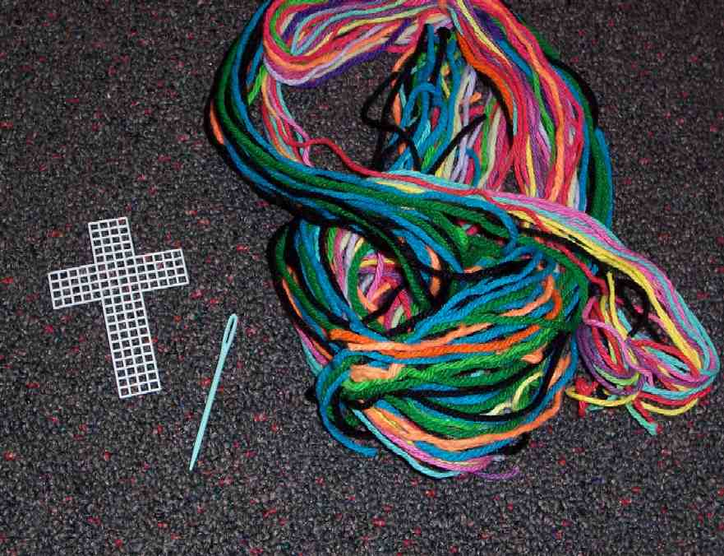
Supplies needed: one plastic or fabric cross patterns per student, needles, yarn

Pass out the supplies to kids and demonstrate how to stitch the plastic canvas grid while discussing the following:

From the drama in large group, what do you know about Mark, the boy who was killed in an automobile accident? (He had come to know Jesus and accepted Him as His Savior before He died.)

How might that knowledge have comforted others at Mark’s funeral? (They know Mark is in a place where there is no pain, sadness or destruction. He is living face to face with Jesus.)

What good came of Mark’s death that was also a comfort to Susan? (Several people, who didn’t know Jesus, saw the peace of those who claimed Him as their Lord and Savior and wanted to know more about becoming a Christian.)

Interpretation Questions: What does this mean?
Read Genesis 50:20 from the NIV translation:
“You meant to hurt me, but God turned your evil into good to save the lives of many people, which is being done.”

Even though this is what Joseph said to his brothers, how could these same words be something Jesus said to Satan? (Even though Satan wanted to destroy Jesus, Jesus’ death is “accomplishing what is now being done, the saving of many lives.”)

How did God turn Jesus’ suffering and death into something good? (Jesus rose again defeating Satan and the power of death. Through Jesus’ death and resurrection, all who believe in Him as their Savior also have eternal life. Jesus’ death meant “the saving of many lives.”)

Application Questions: What does this mean to me?
Think of the Tsunami tragedy and lives lost. God cares so much more about our eternal lives. Have you heard stories about people coming to faith in Jesus because of the survivor’s testimonies? (search internet for ‘testimony-Indonesia Tsunami)

Give examples of types of suffering that may happen in your future that can be hard to understand, and how God might use them for good.

Discuss as you weave your cross.


How does the knowledge of Jesus’ death and resurrection help you when you are going through suffering? How does knowing the promise that *God can turn bad things into good help you?

How can you help others going through suffering?

We can be certain that what Satan intends for evil to harm us, God can turn into good for those who trust in Him. This cross is a reminder that God can turn the messiness of our lives into His perfect plan.

Memory Verse Learning: 5 minutes
Purpose: Help kids to memorize and keep scriptures at heart. Using creative ways to help kids enjoy learning the key verse and in small group setting.

Supplies needed: a small rubber ball

Memory Verse: Romans 8:28 ~ “We know that in everything God works for the good of those who love Him. They are the people He called, because that was His plan.” (NCV)

MV Presentation: “Who’s Got the Ball?”
Form two equal teams, and divide the playing area in half. Give each team a different side of the playing area facing each other. Designate a part of each end of the playing area as the Safe Zone. Before game begins, have each team recite the memory verse.
Gather one team in a tight circle so the other team can’t see what’s happening, and hand one of the children a small ball, such as a rubber ball, that can be fully enclosed in a child’s hands. Have the child hide the ball in his hands, and have the other children hold their hands in a similar way so the other team’s members won’t know who has the ball. On “go,” the children from the circle must run toward the other team’s Safe Zone. The object of the game is for the child with the ball to make it to the other team’s Safe Zone without being tagged. If a child is tagged by someone from the other team on the opposing side of the field, he must open his hands. If the child with the ball is tagged, the ball is given to the other team. If the child with the ball makes it to the Safe Zone, his team gets to keep the ball and play again. Play until both teams have a chance to hide the ball. At the end of the challenge, have each team recite the memory verse again.

Closing Prayer:
Pray for any specific needs or hard times kids mentioned in the discussion. Thank God for Jesus’ death and resurrection and His suffering for our sakes. Thank Him for His promise that He will turn the bad things into good. Pray that we would be reminded that the messiness in our lives could be seen as God’s perfect plan. Pray to trust God in all circumstances.

If any kids are unsure of their salvation, but want to receive Jesus as their Savior, lead them in prayer.

Large Group Presentation

How Could God Let This Bad Thing Happen?
Brief Drama Sketch

Purpose: To demonstrate a simple, practical application of God’s truth, *God can turn bad things into good. This is a short introduction to the Bible event.

Characters: Two teenagers are talking about their friend who was killed two weeks ago in a car accident.

Plot Summary

The story has a simple plot that can be remembered and acted out without memorizing lines.

Thian Yong has been thinking hard about his friend, Wei San, who was killed in an auto accident involving a drunk driver. He is angry with God and cannot understand why God would let this happen. His friend, Tze Ee, points out that Wei San is probably not angry at all because, through his faith in Christ, Wei San is in heaven. She also adds that the funeral was a victory celebration where many people clearly heard God’s love for them and the promise of life forever in heaven with Him after death. It was overwhelming to see grief replaced with hope when people testified about their joy in Jesus even during this bad time. Some of them asked Susan what it means to be a Christian.

Story Board

The large group presenter introduces Thian Yong and Tze Ee who are talking after church.

“Why are you so angry?”
Tze Ee asks Thian Yong why he still seems to be so angry with God. Thian Yong explains that he can’t understand why God would let Wei San get killed by a drunk driver. God could have controlled this and could have stopped him. Doesn’t God have control over evil?

“Wei San is in heaven.”
Tze Ee recalls what the Pastor said at the funeral about how enthusiastically Wei San professed Jesus as his Savior and is certainly in heaven right now in a perfect world. Thian Yong insists that it still doesn’t seem fair.

“Wei San is not angry.”
Tze Ee points out that Wei San is probably not angry about what happened, but is grateful that he is now in heaven because of what Jesus has done for him. Thian Yong responds, “But what good does that do us?”

“The witness at the funeral”
Tze Ee points out that the funeral was a beautiful victory celebration of Wei San’s life and of what Jesus has done. Wei San is now in a perfect place with Jesus forever. She said that Wei San would be glad that, because of his death, other people were drawn to Jesus. Several people had asked Tze Ee what it means to be a Christian and how they could receive Jesus as their Savior. Thian Yong pauses and says, “That helps. I think I have some things to think about.”

Large Group Presentation: 20-30 minutes

Teaching Using Object Lesson

Supplies:
- Yarn
- Grid: a masonry metal or plastic grid about two foot square with holes smaller than chicken wire, but large enough so that thick yarn can easily be woven through by hand making the design of a cross. In advance, weave a cross that on one side looks like a tangled mess of yarn tied to a wire grid, but on the other side is a well-formed cross.
- Bible

Option: Have an adult helper finish weaving the cross revealing only the messy backside while you speak.

Video Presentation: Visual Bible

This section shows the crucifixion of Jesus, especially when He felt forsaken by God. The teaching centers on Genesis 50:20, the Passion of Christ and how Jesus’ death was meant for good.

Show The Visual Bible: Matthew 27:31-50. Start the video when the moderator says, “After they had mocked Him…” and end the clip when the moderator says, “When Jesus cried out in a loud voice, He gave up His spirit.”

After the video section say:

Kids, as you can see, today we are presented with a serious topic as we look at the suffering of Jesus Himself. But we are also looking at other types of suffering and asking the question that you have already talked about, “How could God let this happen?”

If God is so big and powerful, how could He let such suffering happen? How could He let His own Son die, for that matter? Did you hear Jesus crying out on the cross, “My God, My God, why have You forsaken me?” How could God let this happen? Let’s look at that today.

Object Lesson
The presenter teaches while an assistant finishes the yarn cross on a masonry metal grid. One side looks like a jumbled up mess of knots with no pattern, and the other side is a well-formed cross with an obvious stitched pattern. Kids should only be able to see the messy side the leader is working on.

Options: Instead of weaving during the presentation, the leader might have the grid laying out on the table in such a way that the audience can only see its backside, not the intended, surprise result. Or the leader might stitch, with a helper behind the grid, so the yarn can be passed back and forth through the grid to produce the desired effect on each side.

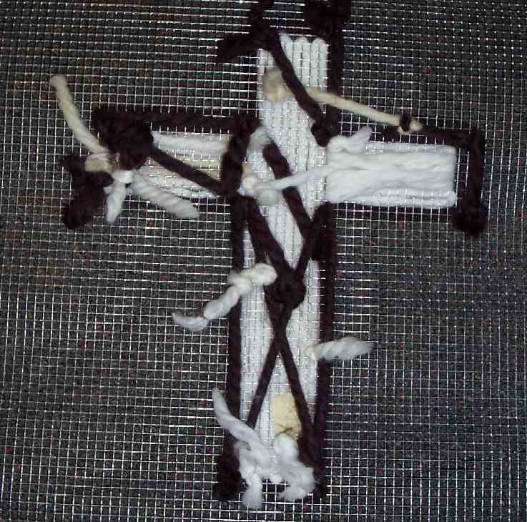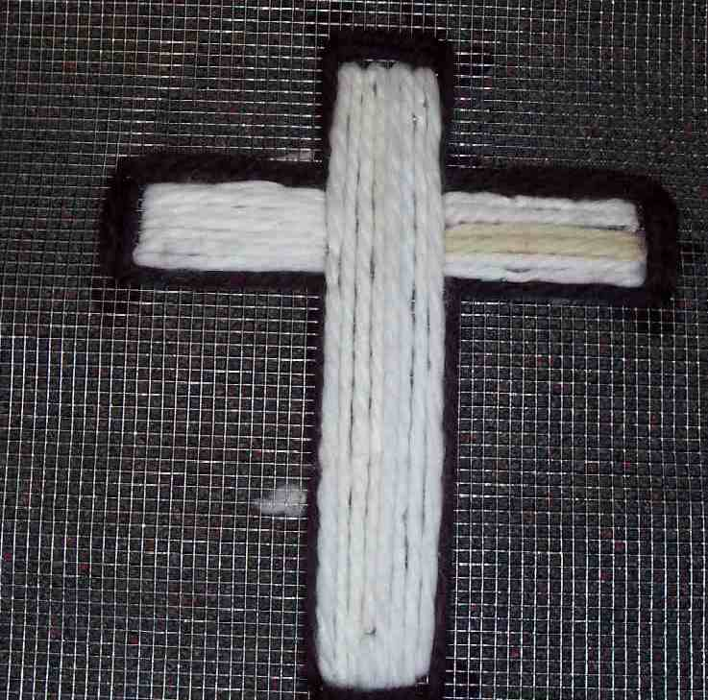

- Review: Joseph

Let’s begin with a truth that we read last week about what Joseph learned from his own suffering.

“But Joseph said to them, ‘Don't be afraid. Can I do what only God can do? You meant to hurt me, but God turned your evil into good to save the lives of many people, which is being done.” Genesis 50:19-20 (NIV)

Joseph was talking to his brothers, but he reflected a truth that every person can have who has a trust relationship with God. In any circumstance, though evil happens, God can turn it to good.

What would be the worst thing that you think could ever happen to someone? May I have a volunteer answer that? (The answer will probably be: death, torture, or perhaps, even hell.)

What Joseph learned was that his brothers intended evil against him but he couldn’t take God’s place to judge them or take vengeance. He had to trust that God had a plan to make something good result from those bad things that happened to him.

The important truth for us to remember today is that: *God can turn bad things into good.

- Application: Jesus

Could God ever turn something even worse than what happened to Joseph, like death or even hell, into good? To explore that concept, let’s look at Jesus’ story.

What are some things you noticed about Jesus’ suffering and dying on the cross? What were some painful things Jesus had to endure?

Take some answers from the kids.

Do you know what happened when Jesus said, “My God, My God, why have You forsaken Me?”

At that time, Jesus was experiencing spiritual death. Spiritual death is separation from God. Spiritual death is what hell feels like. Spiritual death is God turning His back on you.

Did Jesus experience what it was like to have God turn His back on Him?

Yes, Jesus experienced God turning His back on Him. Think about how you feel when you are punished for something wrong that you have done. Maybe you feel like your parent(s) have turned their backs on you. That is how Jesus felt, except that He was completely innocent of any wrongdoing.

That is why we heard Jesus say, “My God, My God, why have You forsaken Me.” He didn’t even call God His father at that point. He cried, “ My God!”

How could any good come out of that?

As you listen to the following, think about how God can turn something as bad as Jesus experiencing spiritual death into something good.

Read (or have a student read) 2 Corinthians 5:21:

“Christ had no sin, but God made Him become sin so that in Christ we could become right with God.”

God is holy and cannot tolerate any unholy or sinful thing. Jesus at that moment took all the sin of the world on Himself so that God will not turn His back on us.

God turned the awfulness of Jesus’ death into good for us. When we have faith in Christ, we won’t experience spiritual death or eternal separation from God because Jesus took it for us.

How can death be turned into something good for us? Death for believers is no longer the end of life; instead it is a beginning. Instead of a tomb, death becomes a doorway into a perfect life with God forever the way He originally designed it.

Do you know Jesus as your Savior? If you do, then you can know for sure, that when you die, you will go to heaven with Him.

- Object Lesson Conclusion

I have been (or my helper has been) tying knots and weaving up here and it looks like a jumbled mess from your side. This is kind of how life on earth sometimes appears. But what appears to be messy and bad from our viewpoint, is God’s perfect design from the heavenly viewpoint. God can make our messes come out for good.

Turn it around and show the outline of the cross from the other side with everything woven in an orderly pattern.

Hold the bad side of weaving over your head outward toward the audience.

This is how life looks sometimes. We look up to God and say, “God, how could You let this happen? How could we have death, destruction, and pain in the world?”

But from God’s perspective, (show the other side of the cross) it is obvious how it all fits together for good.

Closing prayer

Dear God, I know bad things happen in this world because of sin. We all have sinned, but I admit that I have sinned against You. I need You to turn bad things into good. I need Your forgiveness and I need Jesus in my life. Jesus, thank You for taking my sin on Yourself so that the death You died was in my place. Now I can live forever with You and Your Father in heaven. In Jesus’ name, we pray. Amen

Lesson 12
Small Group Warm-Up
- pieces of yarn in a variety of colors (Use in application craft.)

Large Group
- two-foot square masonry metal or plastic grid with holes smaller than chicken wire, but large enough so that thick yarn can easily be woven through by hand making the design of a cross
- thick yarn
- Bible
- video, The Visual Bible: Matthew 27:31-50, produced by Visual Bible International, 1997

Small Group Application
- plastic or fabric cross-stitch canvas in a cross shape, one cross per student
- needles
- yarn

Memory Verse Learning
- small sponge ball

