
Date: _________________________
Series: Seeing God Through Suffering (Jun-Aug)
Year 2, Lesson 14
Joy in the Midst of Suffering

Take Home Point: *You can choose joy even in times of suffering.
*Repeat this phrase throughout the lesson.

Bible Event: 1 Thessalonians 5:16-18 and Philippians 4:4-7
Key Verses: 1 Thessalonians 5:16-18, “Always be joyful. Pray continually, and give thanks whatever happens. That is what God wants for you in Christ Jesus.”

We will help kids know:
- They will face suffering in their lives, but they can choose joy even in such times.
- Happiness is a feeling. Joy is an attitude. We are usually happy only when things go well, but we can choose to have joy any time.
- Joy is a deep confidence that God is in control and loves us.
- To rejoice is to “re-joy” ourselves by remembering what God has done and will do for us.

We will help kids feel:
- Happy because of the joy they have.
- Inspired to choose joy even when they go through hard times.

We will help kids do:
- Pause and think/pray about what God does.
- Make a craft that illustrates seeing joy even in the midst of suffering.
THIS LESSON’S ROADMAP

DESTINATION | PAGE # | DISCOVERIES ON YOUR JOURNEY | SUPPLIES NEEDED
Small Group Warm-Up   | 4 | Students will share experiences with the group about times they have been injured. During discussion, they will pass around a roll of toilet paper and wrap the section of their body that was injured, with a piece of it. | - a roll of toilet paper
Large Group   | 3  9  10  15 | Overview  Storytelling: A View from the Window – The story of two men sharing a room in a hospital, using their imaginations to make the stay more bearable.  Dramatic Sketch for Teaching – The Large Group Presenter interviews two characters and relates Bible verses to the answers of each.  Appendices | - a three-foot by two-foot window pane made out of 1 inch x 1 inch wood strips, yard sticks put together, or pop out a set of window grids you have on your house. The window should have two cross pieces so there are seemingly four panes.  - a hat that is fun and joyful  - a scarf  - two signs with a string attached for characters to hang around their necks: Sign #1 reads: Re-Joy  Sign #2 reads: Po-Me  - interview questions (see appendix)
Small Group Application   | 5 | Students discuss what “joy” means and how it relates to rejoicing in the Lord. The craft they make illustrates how they can have joy in the midst of suffering.  Memory Verse Learning:  “Tightrope Toss”  Romans 8:28 will be repeated for lessons 10 – 14 to reinforce the truth that no matter what happens God always work things out for our good. | - ½ sheet of white manila paper per student  - water based markers (both light and dark colors but not black, brown or yellow)  - black permanent marker  - glue sticks  - toilet paper pieces from Warm-Up cut to eight inches long  - cup of water  - masking tape  - 2 soft balls

Small Group Warm-Up: 15 minutes
Purpose: Get pointed in the right direction! Build relationships and help quests feel at ease. Do the learning readiness activity that will point your group in the right direction for the lesson.
As kids gather: Listen to memory verses from last week and give coupons for memory verses, remembering to bring your Bible, and bringing a guest.

Supplies: Toilet paper roll

Have you ever had an accident or injury? Share your experience. It could be something as simple as falling off your bike or as serious as something that required you to visit the hospital.

As you share your experience with the group, we will pass around this roll of toilet paper. When you get it, take a piece off that is long enough to wrap around the section of your body that was injured. Think of it as a band-aid. So, for example, if you broke your arm, take enough toilet paper to wrap around your arm a few times. It might be difficult to wrap a toe, nose, or ear, but do your best.

When you tell your story about what happened, also tell the group how long you stayed sad or hurt from your injury.

If more discussion is needed to fill the time, continue talking about other times of hurt other than physical injury, when they have experienced suffering. In other words, some of those hurts might not be on the outside but on the inside. Some examples may include the loss of a loved one or hurtful words said by others.

Today we will learn, that even though suffering is hard and we may be sad about a hurt or injury, *we can choose joy even in times of suffering.

Large Group: 20-30 minutes
Purpose: Help kids observe what the Bible says. Present the Bible event in creative fashion. Help kids begin to interpret what it means.

Overview

Storytelling: A View from the Window – The story of two men sharing a room in a hospital, using their imaginations to make the stay more bearable.

Dramatic Sketch for Teaching – The Large Group Presenter interviews two characters and relates Bible verses to the answers of each.
Small Group Application: 20-25 minutes
Purpose: Help kids map out the meaning of the Bible event in their lives. Use the questions to stimulate discussion, but don't feel tied to them. Allow the Holy Spirit to guide you. Include personal examples from your own faith journey. The example of Christ at work in your life will leave lasting impressions of how Christ can work in the children's lives.

Use your Bibles! Children need to learn how to look up references and follow along when scripture is read aloud. Allow for quality time of prayer at the close of the lesson.

Observation Questions: What happened?
We will talk about the story “The Window,” in a minute; but first, let’s read what the Bible says about joy.

Have kids read Philippians 4:4-7.

When should we be joyful? (Philippians 4:4. Always.)

Why can we be joyful always? (Philippians 4:5. Because the Lord is coming.)

Philippians 4:6 tells us not to worry about anything, but with what attitude should we make our requests known to God? (While giving thanks.)

If you pray in this way, how should you feel? (Phil. 4:7. Peaceful beyond anything we can imagine.)

Interpretation Questions: What does this mean?
How was the story, “The Window,” like what happened between Re-Joy and Po-Me? (Discuss)

Is it easy to be joyful? Why or why not?

What does thankfulness have to do with joy? (We can choose to always give thanks. That helps us be more joyful.)

Is there a difference between happiness and joy? (Happiness is how we feel if the situation goes our way. Joy is contentment we have when we trust in God’s best for us even in the middle of suffering.)

Application Questions: What does this mean to me?
What can you do when you feel sad or hurt to “re-joy” yourself? (Discuss.)

What can you do to help others who are sad or hurt to “re-joy or rejoice?” (Discuss.)

Activity:
Supplies: ½ sheet of white manila card per student, water based markers (both light and dark colors but not black or brown), toilet paper pieces from Warm-Up, scissors, and a small bowl of water

Give each student a half sheet of white or light colored manila card paper and a black permanent ink marker. Have them write the word “Joy” in double-lined lettering on the paper. They may need to practice on a piece of draft paper first. As they do this, discuss the meaning of joy.

When you hear the word “joy,” what comes to your mind?

Joy is an attitude that we choose to have. It is a mindset. Joy is a deep confidence in knowing that God is in control. We can have joy when we trust that God loves us no matter what and will help us to experience His best.

As kids write the word “joy,” discuss things God has done that demonstrate His love for us, and that He is in control. (Examples might be: He created me, He provides for me, and especially, He gives me His Son, Jesus. He gives me a future, He gives me parents, He gives me friends and He wants to have a friendship with me that lasts forever.)

When kids have finished writing “joy”, have them close their eyes and pray thank You to Him for what He has done and what He will do. Then explain that when they remember what God has done for them and thank Him, they are “re-joying” themselves. It gives us a deep security in our heart.

How do you feel after the prayer? Is there a joy inside and even a happiness that comes from that?

Joy doesn’t come from just doing something you like, but it is a mindset from remembering God’s good and thanking Him.

Now, let’s go back and think about the sufferings we may have had. We will always have suffering, so think of something you may be afraid of in the future. This might be fear of self or someone else becoming sick and dying, or being the target of a bully at school.

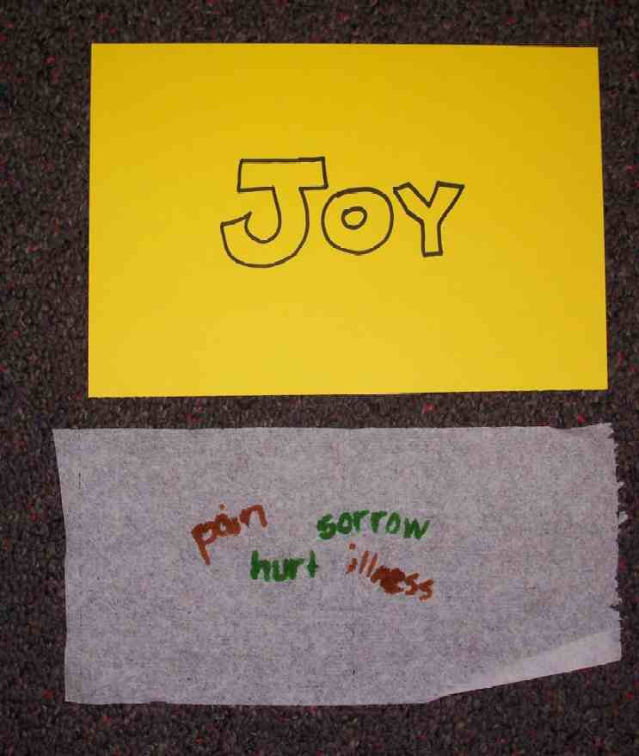

Hand kids a strip of toilet paper.

Write a couple of words on the toilet paper strip in a light color marker (pink, orange, light green, etc) that describe something you are afraid of suffering in the future. Using the glue stick, attach the toilet paper in each corner to the manila card.

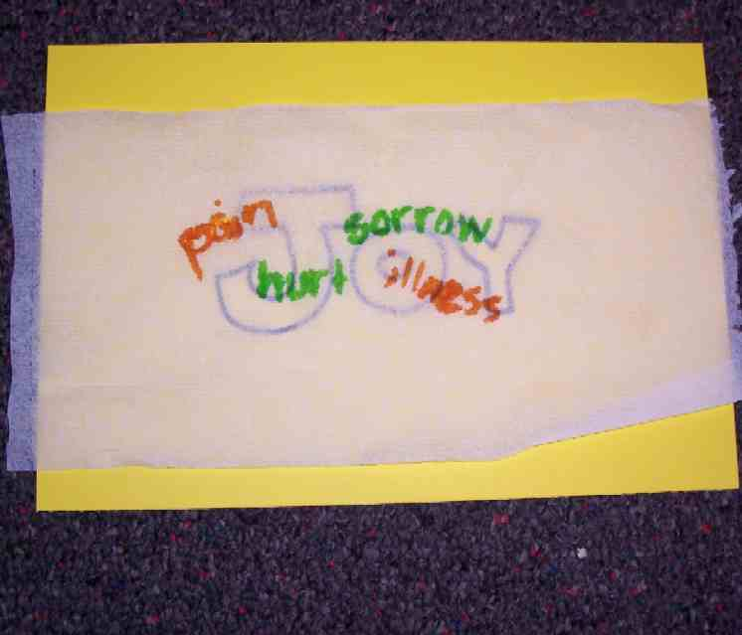

Have kids lay the toilet paper strip over the “Joy” paper. Cut off any excess length. Holding the toilet paper strip still, have kids dip their fingers into the water and let water drops fall onto the toilet paper around the outline of the word “joy.” It helps to pat the absorbed drops gently with another finger as you go. As the toilet paper is moistened, you can see the ink color disperse and blend with the other color, yet, the main outline of “joy” remains. (Leave the toilet paper adhered to the manila card.)

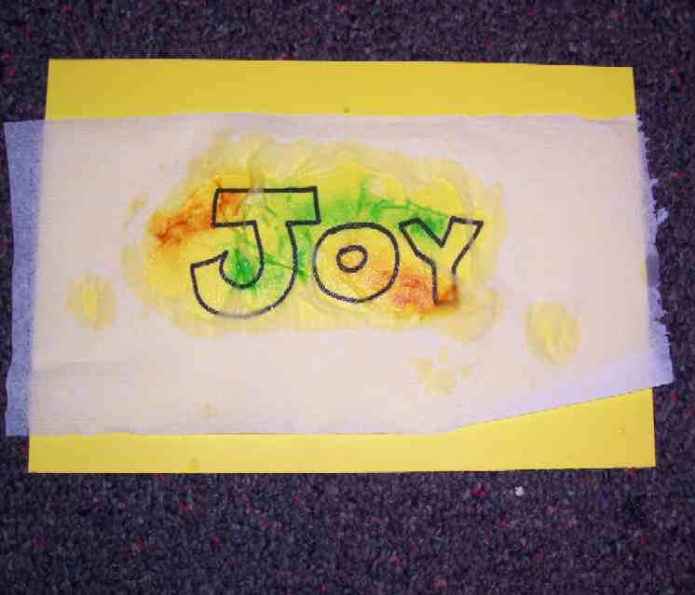
While kids are working on their project, read them the following true story:

This is a true story of a young man named Pete that takes place in the rugged Sawtooth Mountains of Idaho. Pete was on a backpack expedition with his friends high in the mountains where, in some areas, the snow never melts but turns into hard icy patches. On steep mountains, this can be most dangerous.

Pete was crossing such a snow fill when he lost his footing and slid down the mountain at break-neck speeds for a quarter of a mile. He crashed over rocks and into boulders and was almost killed. Amazingly enough, he lived. Still, he had a five-mile walk back to safety. He had no broken bones in his legs but walked with pain because his ribs and internal organs were bruised and damaged. Every step was very difficult and painful. As he walked, sometimes the pain became so unbearable that he stopped and felt sorry for himself. He said in his mind, “Why did this happen to me? This hurts too much. Someone should feel sorry for me. I feel sorry for myself.”

When he did feel sorry for himself, it seemed like his strength gave way and he wanted to do nothing but lie down and cry. But if he did that, surely he would likely never get off the mountain and would freeze in the cold night air with darkness soon approaching.

“I must go on,” he thought. Though he did not feel the strength, he remembered to call upon the Lord for strength and reminded himself that the Lord could work in the middle of any circumstance. He remembered all the things he had for which to be thankful.

As he remembered, he gathered the strength to continue. A Bible verse came to mind. “The joy of the Lord is my strength,” he said over and over in his mind. “The joy of the Lord is my strength…The joy of the Lord is my strength.” He recounted the blessings of being alive and even though he was hurt, he knew he would live. Finally, he made it down the mountain.
After several days in the hospital, and for weeks afterward, even when he was in pain, he experienced a level of joy he never felt in his life. He looked at small things around him, such as the color of a leaf and the shape of a cloud. He saw things beautiful like they never were before. He said that he didn’t realize there was a joy that came down deep in his soul that did not depend on circumstances around him or even how much pain he had. There was a deep contentment that God was in control and he had peace in his heart.

Have kids look at their craft and point out that a color pattern of joy can be seen right through the suffering. Then say:

The Bible says in 1 Thessalonians 5:16-18, “Always be joyful. Pray continually, and give thanks whatever happens. That is what God wants for you in Christ Jesus.”

Today we learned that *we can choose joy even in times of suffering.

Memory Verse Learning: 5 minutes
Purpose: Help kids to memorize and keep scriptures at heart. Using creative ways to help kids enjoy learning the key verse and in small group setting.

Supplies needed: masking tape, 2 soft ballsl

Memory Verse: Romans 8:28 ~ “We know that in everything God works for the good of those who love Him. They are the people He called, because that was His plan.” (NCV)

MV Presentation: “Tightrope Toss”
Before the class, create a 5-foot square or triangular "tightrope" on the floor using masking tape. Direct the children to line up on the tightrope. Hand two children the balls. Before the game begins, have all the children recite the memory verse. Say: “In this death-defying circus act, you must walk the wobbly tightrope as you toss the balls to each other! If you drop a ball or step off the tightrope, you are out.” The shepherd may call out directions such as "hop," "change directions," or "walk backward." Tightrope walkers must follow those directions. We'll play until there are only two tightrope walkers left. At the end of the game, have all the children recite the verse again.

Closing Prayer:
Heavenly Father, help us to practice and perfect the attitude of joy. We know it’s difficult sometimes, but when we know Your strength is with us, it is easier to be joyful. We ask that as we practice being joyful in all circumstances, it becomes easier and easier to rejoice. When we forget and fall into the trap of self-pity, please send a gentle reminder that You are in control and that we have the tools we need to have joy in our hearts. In Jesus’ name. Amen.

Large Group Presentation

The Window

Storytelling

Props: You will need a three-foot by two-foot windowpane made out of 1 inch x 1 inch wood strips, yard sticks put together, or pop out a set of window grids you have on your house. The window should have two cross pieces so there are seemingly four panes. Use the window as a prop as you tell the story.

There were once two men, both seriously ill, in the same small room of a great hospital. Quite a small room, just large enough for the pair of them – two beds, two bedside lockers, a door opening on the hall, and one window looking out on the world.
One of the men, as part of his treatment, was allowed to sit up in bed for an hour in the afternoon (something to do with draining the fluid from his lungs), and his bed was next to the window.
But the other man had to spend all his time flat on his back – and both of them had to be kept quiet and still which was the reason they were in the small room by themselves. They were grateful for peace and privacy – none of the bustle and clatter and prying eyes of the general ward for them.
Of course, one of the disadvantages of their condition was that they weren’t allowed to do much: no reading, no radio, certainly no television – they just had to keep quiet and still, just the two of them.
Well, they used to talk for hours and hours – about their wives, their children, their homes, their jobs, their hobbies, their childhoods, what they did during the war, where they’d been on vacations – all that sort of thing. Every afternoon, when the man in the bed next to the window was propped up for his hour, he would pass the time by describing what he could see outside. And the other man began to live for those hours.
The window apparently overlooked a park with a lake, where there were ducks and swans, children throwing them bread and sailing model boats, and young lovers walking hand in hand beneath the trees. There were flowers and stretches of grass, games of softball, people taking their ease in the sunshine, and right at the back, behind the fringe of trees, a fine view of the city skyline.
The man on his back would listen to all of this, enjoying every minute – how a child nearly fell into the lake, how beautiful the girls were in their summer dresses, then an exciting ball game, or a boy playing with his puppy. It got to the place that he could almost see what was happening outside.
Then one fine afternoon when there was some sort of parade, the thought struck him: Why should the man next to the window have all the pleasure of seeing what was going on? Why shouldn’t he get the chance?
He felt ashamed, and tried not to think like that, but the more he tried, the worse he wanted a change. He’d do anything!
In a few days, he had turned sour. He should be by the window. He brooded, and couldn’t sleep, and grew even more seriously ill - which none of the doctors understood.
One night as he stared at the ceiling, the other man suddenly woke up, coughing and choking, the fluid congesting in his lungs, his hands groping for the button that would bring the night nurse running. But the man watched without moving.
The coughing racked the darkness – on and on – choked off – then stopped – the sound of breathing stopped – and the man continued to stare at the ceiling.
In the morning, the day nurse came in with water for their baths and found the other man dead. They took away his body, quietly, no fuss.
As soon as it seemed decent, the man asked if he could be moved to the bed next to the window. And they moved him, tucked him in, and made him quite comfortable, and left him alone to be quiet and still.
The minute they’d gone, he propped himself up on one elbow, painfully and laboriously, and looked out the window.
It faced a blank wall.

From The Window and Other Essays, copyright © Pacific Press, Nampa, Idaho. Used by limited permission.

Re-Joy and Po-Me
Dramatic Sketch for Teaching

Props: window pane from first storytelling, a crazy hat that demonstrates joy or fun and a plain scarf, two signs (“Re-Joy” and “Po-Me”) with a string attached for characters to hang around their necks, interview question sheets for each character (see appendix)

Recruit two volunteers from the audience and quickly costume them with headgear and a sign (Re-Joy receives the crazy hat; tie scarf on Po-Me). Have both of them sit up front in chairs. Hand each his/her interview question sheet.

Large Group Presenter:

Ladies and Gentlemen, I introduce to you two attitudes that we all face.
Point out each character as each is introduced.

One is Re-Joy and the other is Po-Me.

Re-Joy reminds us of what we do to have joy in any and all circumstances. To be “joyful always” means that when we practice joy, we re-joy ourselves and even rejoice!

Po-Me is short for “poor me” and is the attitude of self-pity.

Let’s interview these candidates and read scripture as we go. The first scripture verse we read is from John 16:33:

“…I told you these things so that you can have peace in Me. In this world you will have trouble, but be brave! I have defeated the world.”

Question #1:
Re-Joy
Will you have trouble? Yes.

Po-Me
Will you have trouble? Yes.

Question #2:
Re-Joy
When you face trouble, will you be happy? No.

Po-Me
When you face trouble, will you be happy? No.

Question #3:
Re-Joy
When you face trouble, will you be joyful? Yes.

Po-Me
When you face trouble, will you be joyful? No.

Question #4:
Re-Joy
Why can you still be joyful even when bad things happen? Jesus overcame the world.

Po-Me
Why can’t you try and be joyful even when bad things happen? Poor me, I can’t be joyful because things go badly. Things are always going badly for me.
Question #5:
Re-Joy
Look at this window. What do you see? I see a cross that reminds me Jesus won the victory for me.

Po-Me
Look at this window. What do you see? I see a blank wall.

1 Thessalonians 5:16 says, “Always be joyful.”

Question #6:
Re-Joy
How often will you be joyful? Always.

Po-Me
How often will you be joyful? I will be joyful only when things go my way.

We continue on with 1 Thessalonians 5:17, “Never stop praying.”

Question #7:
Re-Joy
How often will you pray? Always.

Po-Me
How often will you pray? Why pray? God won’t hear poor little old me.

Question #8:
Re-Joy
When will you be joyful? I will be joyful in all circumstances.

Po-Me
When will you give thanks? I will give thanks only when things go right.

According to the Bible in 1 Thessalonians 5:18, we are told:

“....and give thanks whatever happens. That is what God wants for you in Christ Jesus.”

Question #9:
Re-Joy
Why will you be thankful? I will be thankful l because it is God’s will.

Po-Me
Why will you do all of this? I won’t do it. Can’t you just feel sorry for me?

Philippians 4:4-7 says,

“Be full of joy in the Lord always. I will say again, be full of joy. Let everyone see that you are gentle and kind. The Lord is coming soon. Do not worry about anything, but pray and ask God for everything you need, always giving thanks. And God's peace, which is so great we cannot understand it, will keep your hearts and minds in Christ Jesus.”

Question #10
Re-Joy
To sum it up, what will you do? Rejoice in the Lord always.

Po-Me
To sum it up, what will you do? I’ll just feel sorry for myself.

Prayer:

Dear God,
Help us to be joyful in You always and in all circumstances. We love to give thanks to You and when we do, it gives us the chance to practice the attitude of joy. We know and expect to have trouble in this world. But since Jesus overcame the world, we can have the peace in our hearts that goes beyond our own understanding and remains with us always. In Jesus’ name. Amen.

Lesson 14
Small Group Warm-Up
- a roll of toilet paper

Large Group
- a three-foot by two-foot window pane made out of 1 inch x 1 inch wood strips, yard sticks put together, or pop out a set of window grids you have on your house. The window should have two cross pieces so there are seemingly four panes.
- a hat that is fun and joyful
- a scarf
- two signs with a string attached for characters to hang around their necks: Sign #1 reads: Re-Joy
Sign #2 reads: Po-Me
- interview questions (see appendix)

Small Group Application
- ½ sheet of white manila paper per student
- water based markers (both light and dark colors but not black, brown or yellow)
- black permanent marker
- glue sticks
- toilet paper pieces from Warm-Up cut to eight inches long
- cup of water

Memory Verse Learning
- masking tape
- 2 soft balls

Appendix A

Large Group
Interview Questions and Answers

Character: Re-Joy
Hint: Use your joyful tone of voice.

- Will you have trouble? Yes.
- When you face trouble, will you be happy? No.
- When you face trouble, will you be joyful? Yes.
- Why can you still be joyful even when bad things happen? Jesus overcame the world.
- Look at this window. What do you see? I see a cross, which means that Jesus won the victory for me.
- How often will you be joyful? Always.
- How often will you pray? Always.
- When will you be joyful? In all circumstances.
- Why will you be joyful? It’s God’s will.
- To sum it up, what will you do? Rejoice in the Lord always.

Appendix B

Large Group
Interview Questions and Answers

Character: Po-Me

Hint: Use your “whining” voice.

- Will you have trouble? Yes.
- When you face trouble, will you be happy? No.
- When you face trouble, will you be joyful? No.
- Why can you still be joyful even when bad things happen? Poor me, I can’t be joyful when things go badly. Things always go badly for me.
- Look at this window. What do you see? A blank wall.
- How often will you be joyful? Only when things go my way.
- How often will you pray? Why pray? God won’t hear poor little ol’ me.
- When will you give thanks? Only when things go right.
- Why will you do all this? I won’t do it. Won’t you feel sorry for me instead?
- To sum up, what will you do? I’ll just feel sorry for myself.

