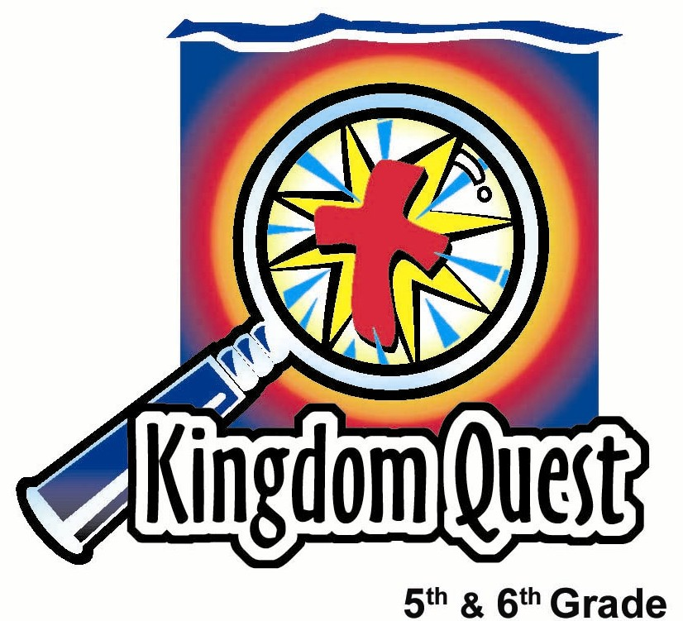
Date: _____________________________
Series: Sharpening your Sword (Dec-Feb)
Year 2, Lesson 34
The Bible’s Purpose—What’s the Point?

Take Home Point: *The Bible shows us Jesus, our Savior, and how to follow Him. *Repeat this phrase throughout the lesson.

Bible Event: Ephesians 6:17, John 20:30-31, 2 Timothy 3:16-17
Key Verse: John 20:31, “But these are written so that you may believe that Jesus is the Christ, the Son of God. Then, by believing, you may have life through His name.”

We will help kids know:
- God wanted to communicate to us so He inspired writers to write down His word.
- The first purpose of the Bible is to point to Jesus as the way to heaven and the way to know God.
- The second purpose of the Bible is to show us how to follow Jesus, giving us a guide for living.

We will help kids feel:
- Motivated to learn more about the Bible and how to use it.
- Curious about learning about the Bible.

We will help kids do:
- Talk about how they use their Bibles at home, discussing any questions they have about the Bible.
- Make a bookmark saying: The Way to Eternal Life.
- Investigate what the Bible says about its purpose.

THIS LESSON’S ROADMAP

DESTINATION | PAGE # | DISCOVERIES ON YOUR JOURNEY | SUPPLIES NEEDED
  Small Group Warm-Up | 3 | Kids will be tricked into looking for a book in the Bible that doesn’t exist. They are challenged to learn the books in the Bible during the next weeks. The Bible will be referred to as a “sword.” | - sword skewers or toothpicks  - snack that can be stabbed with skewers e.g. fishballs or grapes  - Bibles  - pop quiz (Appendix A)  - pencils or pens
Large Group   | 4  7  13 | Overview  Zaro, the Magnificent, teaches students that the Bible is a sword of the Spirit with two main purposes: to point the way to eternal life through Jesus and to show believers how to live like Christ. Kids are challenged to memorize the books of the Bible in the next weeks.  Appendices | Costume:  - black cape and mask  Props:  - toy telescopic lance  - Bible  - freestanding or propped sign with an arrow pointing “to heaven” (Appendix B)  - cue cards for interactive acting game (Appendix C)  - rebus puzzle (Appendix D)  - a large road map
Small Group Application   | 5 | Kids will make bookmarks to keep in their own Bibles with a list of the books of the Bible on the back to help them memorize and as a quick reference tool.  Memory Verse Learning:  “Let’s Connect”  Jeremiah 29:11 will be repeated for lessons 33-37 to help children to learn to feel confidence in the promises of God for the present and the future. | - bookmark pattern (Appendix E)  - markers  - scissors  - hole punch  - labels for Bible’s books  - yarn or ribbon for tassels  - red and blue manila cardboards  - scissors  - Blue tac  - marker  - ruler  - mahjong paper

Small Group Warm-Up: 15 minutes
Purpose: Get pointed in the right direction! Build relationships and help guests feel at ease. Do the learning readiness activity that will point your group in the right direction for the lesson.

As kids gather: Listen to memory verses from last week and give coupons for memory verses, remembering to bring your Bible, and bringing a guest.

Supplies: sword skewers or toothpicks; snack that can be stabbed with skewers e.g. fishballs or grapes; Bibles; pop quiz (Appendix A); pencils or pens

Each child should have a Bible. If not available, have no more than two share one Bible.

Open your Bibles to Hezekiah 6:17.

Let the kids struggle with trying to find this verse and then explain you tricked them. There is no book of Hezekiah in the Bible, although there is a King Hezekiah.

Today we begin a new series to help us become more familiar with the Bible. We will even learn more about the purpose of the Bible.

Get your Bibles in hand and prepare yourselves for a speed drill. I will give you a book and passage to find, and the first person to get to it will be awarded a special sword snack. This time the books and verses to find are not tricks.

Are your Bibles ready? Are you fingers feeling fast? Okay. The first passage to find is Ephesians 6:17. On your mark… get set…. Go!

When kids have found the passage, have them mark it with their finger. Wait until everyone has located the passage (have those with more experience help those that need it). Then have the first child who found Ephesians 6:17 read it aloud.

Award the sword snack to the winner!

How is the word of God described in this verse? (The sword of the Spirit.)

From now on, we will call our Bibles our “swords.”

Hold up the Bible and say:

This is the “sword of the Spirit,” and we want to learn to use it better. Let’s begin by passing out tiny plastic swords and letting everyone take a stab at these snacks. But you can only take a snack as you answer a question about your sword.

Does everyone have a Bible at home… excuse me, a “sword” at home? If you do, get ready to describe what your sword looks like.

- Is it rusty or dusty? If it is, this means that you don’t read it very often.
- Is it heavy? If it is, this means that you don’t understand it.
- Is it in the scabbard? If it is, this might mean that you use it only occasionally, for example just bringing it to church. Or,
- Is your sword polished and ready? If it is, this means that you keep it in good condition and have it ready to use several times a week.

Let’s discuss what kind of condition your sword is in at home.

Have kids pick the best description from above to describe how they use their Bibles.

Pass out the “pop quiz” (Appendix A) and have students answer the questions. Explain that they are to place the letter “B” next to every actual Bible verse, and an “X” by verses not from the Bible. When kids are finished taking the quiz, go through the questions by reading them aloud and have kids raise their hands to indicate their answers, either “B” or “X”. The only genuine Bible verses are the last two on the page. (See Proverbs 24:26 and Hebrews 12:6).

Over the next several weeks, you will be challenged to memorize the books of the Bible and to read it more. When you go to Large Group today, you’ll learn that *The Bible shows us Jesus, our Savior, and how to follow Him.

Large Group Overview: 20-30 minutes
Purpose: Help kids observe what the Bible says. Present the Bible event in creative fashion. Help kids begin to interpret what it means.

Zaro, the Magnificent, teaches students that the Bible is a sword of the Spirit with two main purposes: to point the way to eternal life through Jesus and to show believers how to live like Christ. Kids are challenged to memorize the books of the Bible in the next weeks.

Small Group Application: 20-25 minutes
Purpose: Help kids map out the meaning of the Bible event in their lives. Use the questions to stimulate discussion, but don't feel tied to them. Allow the Holy Spirit to guide you. Include personal examples from your own faith journey. The example of Christ at work in your life will leave lasting impressions of how Christ can work in the children's lives.

Use your Bibles! Children need to learn how to look up references and follow along when scripture is read aloud. Allow for quality time of prayer at the close of the lesson.

Observation Questions: What happened?
What are two purposes of the Bible? (To point to Jesus as the way to eternal life and to give us direction for life or to show us how to follow Jesus.)

Read John 20:30-31.
What reason did John give for recording the miracles of Jesus? (So we will believe that Jesus is God’s Son and that by believing in Him we will have eternal life.)

Read 2 Timothy 3:16-17.
What proof does this passage give that scripture is truly God’s word, not just the words of men? (Verse 16 says that God inspired all scripture.)

Give specific ways this passage tells how God’s word shows us how to live life. (God’s word teaches us, points out our errors, gives us the correct way to live, trains us how to live God- pleasing lives, and equips us to do good things.)

Interpretation Questions: What does this mean?
Why do you think Ephesians 6:17 refers to God’s word as the sword of the Spirit? How can God’s word be used like a sword? (See also Hebrews 4:12. God’s word is the truth that is a weapon against the lies of Satan.)

Application Questions: What does this mean to me?
Application activity
Supplies: printed bookmark pattern on heavy paper (see Appendix D), markers for coloring, scissors, hole punch, stickers for the back of the bookmarks with the Bible’s books listed, and yarn or ribbon for tassels.

Have kids make bookmarks to use and keep in their own Bibles. On the back of the bookmarks are listed the books of the Bible. Encourage kids to use them to memorize the order of the books of the Bible and keep as a quick reference tool for the future.
While kids are making their bookmarks discuss:

What is one new thing you learned today?

How will you use your sword differently than you have in the past?

Restate the take home point: *The Bible shows us Jesus, our Savior, and how to follow Him. Let’s learn to use it as the sword of the Spirit.

Memory Verse Learning: 5 minutes
Purpose: Help kids to memorize and keep scriptures at heart. Using creative ways to help kids enjoy learning the key verse and in small group setting.

Supplies needed: mahjong paper, red and blue manila cardboards, scissors, glue tac, marker and ruler

Memory Verse: Jeremiah 29:11 ~ “I say this because I know what I am planning for you," says the Lord. "I have good plans for you, not plans to hurt you. I will give you hope and a good future.” (NCV)

MV Presentation: “Let’s Connect”
Prior to class, draw a large grid on the mahjong paper, six squares by seven squares. It will look like an oversized tic-tac-toe board. Cut the red and blue manila cardboard to make circles about the size of the squares on the grid. Make 20 red and 20 blue circles.
The boys will use the blue circles and the girls will use the red circles. Explain that the game is played like a tic-tac-toe, only they need to get four of their circles in a row on the grid. The row can be vertical, horizontal or diagonal. The circles are applied to the mahjong paper using Blue tac. Before the game begins, have all the children recite the memory verse several times. Then have the girls recite the verse follow by the boys. Hand each child a circle according to the color. Before a child can play, he/she must recite the memory verse. Determine who will go first and alternate turns. The first group with four in a row is the winner. Close by reciting the memory verse as a group.

Closing prayer:
In addition to personal prayer requests, encourage kids to pray for the Holy Spirit to give them incentive to study God’s word and to memorize the books of the Bible.

Thank God that He points us to Jesus and eternal life through the Bible. Thank Him that He wants to have a friendship with us now and forever.
Safety and Security: Safety and security procedures are important for each church to carefully define and implement according to their unique needs. The security, safety, illness and accident procedures described in this curriculum are provided for example purposes only and may not be appropriate, applicable or adequate for every situation. Each church is responsible for determining whether any security, safety, illness and accident procedures contained in the curriculum are appropriate, applicable or adequate for its unique situation. The activities described in this curriculum require adult supervision and may not be suitable for each child and each situation. Each church is responsible for ensuring that adequate adult supervision is provided for all activities and for determining whether an activity is appropriate for each child and each situation. Kids Kount Publishing disclaims all liability for the implementation of any procedures or the performance of any activities described in this curriculum.
Large Group Presentation

Sharpening Your Sword
Interactive Teaching

Costume:
- simple black cape and a black mask to resemble the Zoro character

Props:
- toy telescopic plastic lance that extends when flipped forward or possibly another option of a telescopic antenna rigged to a homemade sword handle (used for pointing out the key verses of the Bible)
- Bible as the sword
- Rebus puzzle: (Appendix D) “Eternal Life”
- A large road map
- freestanding or propped sign that looks like a “One Way” sign with an arrow pointing “ To Heaven” (Appendix B)
- two cue cards for interactive acting game (see Appendix C)
  - First purpose of the Bible - To show… Jesus is the way to heaven
  - Second purpose of the Bible - To show… how to follow Jesus

Please send a note home to parents to encourage practice and memorization of the Bible’s books. The bookmarks will help as a memorizing tool (See Appendix E).

Introduction: Zaro! the Magnificent!

Large group leader enters dramatically in a flying cape, showing off his costume and toy sword. Have a Bible nearby on a table.

Hello, I am Zaro! the Magnificent! I’m sure you can obviously see that for yourselves, just by looking at my magnificent costume and more importantly, my magnificent sword! Ah yes…my sword! Without my sword, I would not be magnificent at all. I would NOT be Zaro! I would be ZERO! But, WITH my sword, I am able to cut to the truth of life’s important issues. WITH my sword, I am able to point the way to heaven itself. And WITH my sword, I am able to fend off the enemy and all his lies and deceptions. All this, and more, is available to you with the one true Lord and Savior.

I understand that you all had a little competition already today. So, you already have some sword experience under your belt. You found the verse from Ephesians 6:17 that says, “Accept God's salvation as your helmet, and take the sword of the Spirit, which is the word of God.”

Show the Bible in one hand and the toy sword in the other. Make the comparison that the Bible is the sword of the Spirit.

The problem is that many of us don’t know much about our sword or how to use it. For the next several weeks, we will explore this issue and see what can be done to sharpen our swords.

Series challenge

I have a challenge for you that I know will be a perfect way to polish and sharpen those swords! I hear that you are excellent competitors so this task of finger flexing, fact finding, truth enabling, double dexterity mental metamorphosis into efficient Bible bungee jumpers of God’s word will be a piece of cake – or at least worthy of the honorable sword snack.

That challenge is to know and memorize the books of the Old Testament and the New Testament in five weeks. Don’t be scared. You have all these qualified people, and me, Zaro the Magnificent, surrounding you and helping you. We will have some fun along the way! We will even send a note home to your parents encouraging them to help you practice this at home. Practice will help you memorize the books of the Bible to get around your Bible quickly and easily.

To begin with today, I have this special gift for anyone who can recite the books of the Bible without error, until I tell you to stop.

If you have several children wishing to try, take one through one section of the Bible and reward them with a little gift. Seat them and then bring someone else up. If anyone makes a mistake, then you can have another person come up. Reward all kids that are successful. This is primarily for the purpose of showing that some kids already know the order of the books of the Bible and can hopefully encourage others to learn them, too.

Next week, we will play a game in which every small group competes as a unit. We’ll see which group knows the books of the Old Testament the best. So for the duration of this week, it is important to practice memorizing the books of the Old Testament. You will leave with a handy bookmark to help with that.

Purpose of the Bible
Today my question is: What is the purpose of the Bible? There are two main purposes of the Bible. Here are two clues to the first purpose.

Clue #1
Show the sign pointing to heaven.

The Bible is like a road sign that points us in the right direction to somewhere. Where is the Bible pointing?

The Bible is not the way to heaven or the way to eternal life but it is a sign that points us in the way to eternal life. The sign points to Jesus.

In John 14:6 Jesus says, “"I am the way, and the truth, and the life. The only way to the Father is through Me.”

Clue #2
Show the rebus puzzle that you’ve enlarged for the chalkboard, overhead, or erasable board. Ask:

What does this rebus puzzle say?

Let several kids try and solve the puzzle. The answer is: Eternal Life

John 17:3 says, “And this is eternal life: that people know You, the only true God, and that they know Jesus Christ, the One You sent.”

The Bible shows us how to get eternal life because it points to Jesus. From the very beginning to the end, the Bible is all about how God made a way for us to have eternal life with Him. Eternal life is life with God in heaven, but it is also life with God right now. What God wants more than anything else is to have a friendship with us, not just in heaven, but also with us right now. The only way to receive eternal life is to know Jesus as Savior.

Second Purpose of the Bible:
We can find the second purpose of the Bible in 2 Timothy 3:16-17 which says, “All Scripture is given by God and is useful for teaching, for showing people what is wrong in their lives, for correcting faults, and for teaching how to live right. Using the Scriptures, the person who serves God will be capable, having all that is needed to do every good work .”

Interactive game – Charades

We are now going to play a short game of charades to summarize the two purposes of the Bible.

Invite two volunteers to the front, one boy and one girl. Give each a clue card and as they read it, tell the audience that the boys should guess the actions of the boys’ team and the girls should guess the actions for the girls’ team. Remind them that if they forget this and give an answer to the other team, it will only hurt their team’s score.

Have the boy volunteer pantomime what is written out on the clue card. Have the boys only guess the first purpose of the Bible. Offer only one hint; that it begins with: “The first purpose of the Bible is to show…”

- First purpose of the Bible - To show… Jesus is the way to heaven.

Next, the girl volunteer acts out the second purpose of the Bible in the same way as girls in the audience make guesses. Begin again with the hint: “The second purpose of the Bible is to show...”

- Second purpose of the Bible - To show… how to follow Jesus.

Review first purpose: The Bible points the way to heaven.

I’d like to conduct an experiment now. Listen carefully to how it works. For about 20 seconds, I’d like everyone in the room to describe to me as loudly as you can, all at the same time, the directions to your house. Think about it… are you ready? Get set, and, GO!

While kids are giving directions out loud, say in a soft voice;

God loves you and He wants to be your friend now and forever in heaven. Trust Jesus as your Savior as the only way to heaven.

Okay, and... stop! It sounded pretty chaotic in this room, didn’t it? That’s because there were too many people giving directions all at once. Because of that, you didn’t hear what anyone else said, or what I said. Here is what I said, “God loves you and He wants to be your friend now and forever in heaven. Trust Jesus as your Savior as the only way to heaven.” The first purpose of the Bible is …

Point to the freestanding or propped sign.

It points the way to heaven and is another way of telling us how to be friends with God. Now, what is the way for us to get to heaven? What is the way for us to be friends with God? Jesus said, “I am the way, the truth, and the life. No one goes to the Father except through me.”

John 20:31 says, “But these are written so that you may believe that Jesus is the Christ, the Son of God. Then, by believing, you may have life through His name..”

The Bible isn’t the way, but Jesus is the way. The Bible just points the way to heaven.
Let’s imagine that you want to go to ______(name of town) Outside of town, there is a sign that says, “_______ (name of town)15 Miles.” When you get up to the sign, you see someone sitting on top of it and ask, “What are you doing?” They say that they are on their way to ________because that’s the way the arrow is pointing.

You say, “Sitting on the sign doesn’t get you on your way to ______. The sign shows you the way to go to ________.”

This is the same as saying that you are on your way to heaven just by doing what it says in the Bible. That’s not true. The Bible is only the road sign that shows us Jesus, the heavenly way.

Review second purpose: The Bible shows how to follow Jesus.
Unfold and display a roadmap.

But the second purpose of the Bible is to guide us in how we follow Jesus, like a roadmap. As I’m on the road following Jesus and trusting Him as my Savior, sometimes I need to know what God wants me to do. The Bible helps to show me that.

So, the first purpose of the Bible is to point to Jesus as the way to heaven. The second purpose of the Bible is to show us how to follow Jesus. It gives us a guide for living. The Bible is a roadmap of directions for life.

If you’re on a journey and you’re confused about the way to go, then you can use a map and find the right… ________________. The right what? (Direction.)

Refer to the Bible as the direction for life.

The Bible not only is a sign that points us to our destination, eternal life, but as we go along the road, it gives us directions for our… ___________________. Directions for our what? (Life.)

Let’s pray.

Dear God, thank You for Your word that You give us to point the way to heaven through trusting in Jesus as our Savior. Thank You that Your word is also like a roadmap for life that gives us direction and shows us the way to follow in Jesus’ footsteps. Help us these next several weeks to grow in Your word, to sharpen our swords. In Jesus’ name. Amen.

Lesson 34
Small Group Warm-Up
- sword skewers or toothpicks
- snack that can be stabbed with skewers e.g. fishballs or grapes
- Bibles
- pop quiz (Appendix A)
- pencils or pens

Large Group
Costume:
- black cape and mask

Props:
- toy telescopic lance
- Bible
- freestanding or propped sign with an arrow pointing “to heaven” (Appendix B)
- cue cards for interactive acting game (Appendix C)
- rebus puzzle (Appendix D)
- a large road map
Costume:

Small Group Application
- bookmark pattern (Appendix E)
- markers
- scissors
- hole punch
- labels for Bible’s books
- yarn or ribbon for tassels

Memory Verse Learning
- red and blue manila cardboards
- scissors
- Blue tac
- marker
- ruler
- mahjong paper

Appendix A –

Bible Quiz
What’s in the Bible?

Put a letter “B” by the verses that you think are in the Bible and an “X” by the verses that you don’t think are in the Bible.

- “Treat your body with due respect, for remember, cleanliness is next to godliness.”

- “Tell the one who does not work God helps those who help themselves.”

- “Giving a straight answer is like a kiss on the lips.”

- “The Lord disciplines everyone He loves. He severely disciplines everyone He accepts as His child.”

---------------------------------------------------------------------------------------------------------------------

Bible Quiz
What’s in the Bible?

Put a letter “B” by the verses that you think are in the Bible and an “X” by the verses that you don’t think are in the Bible.

- “Treat your body with due respect, for remember, cleanliness is next to godliness.”

- “Tell the one who does not work God helps those who help themselves.”

- “Giving a straight answer is like a kiss on the lips.”

- “The Lord disciplines everyone He loves. He severely disciplines everyone He accepts as His child.”

Appendix B

To Heaven

Appendix C
Two cue cards for interactive charades game.

First purpose of the Bible –
To show… Jesus is the way to heaven

Second purpose of the Bible –
To show… how to follow Jesus

Appendix D
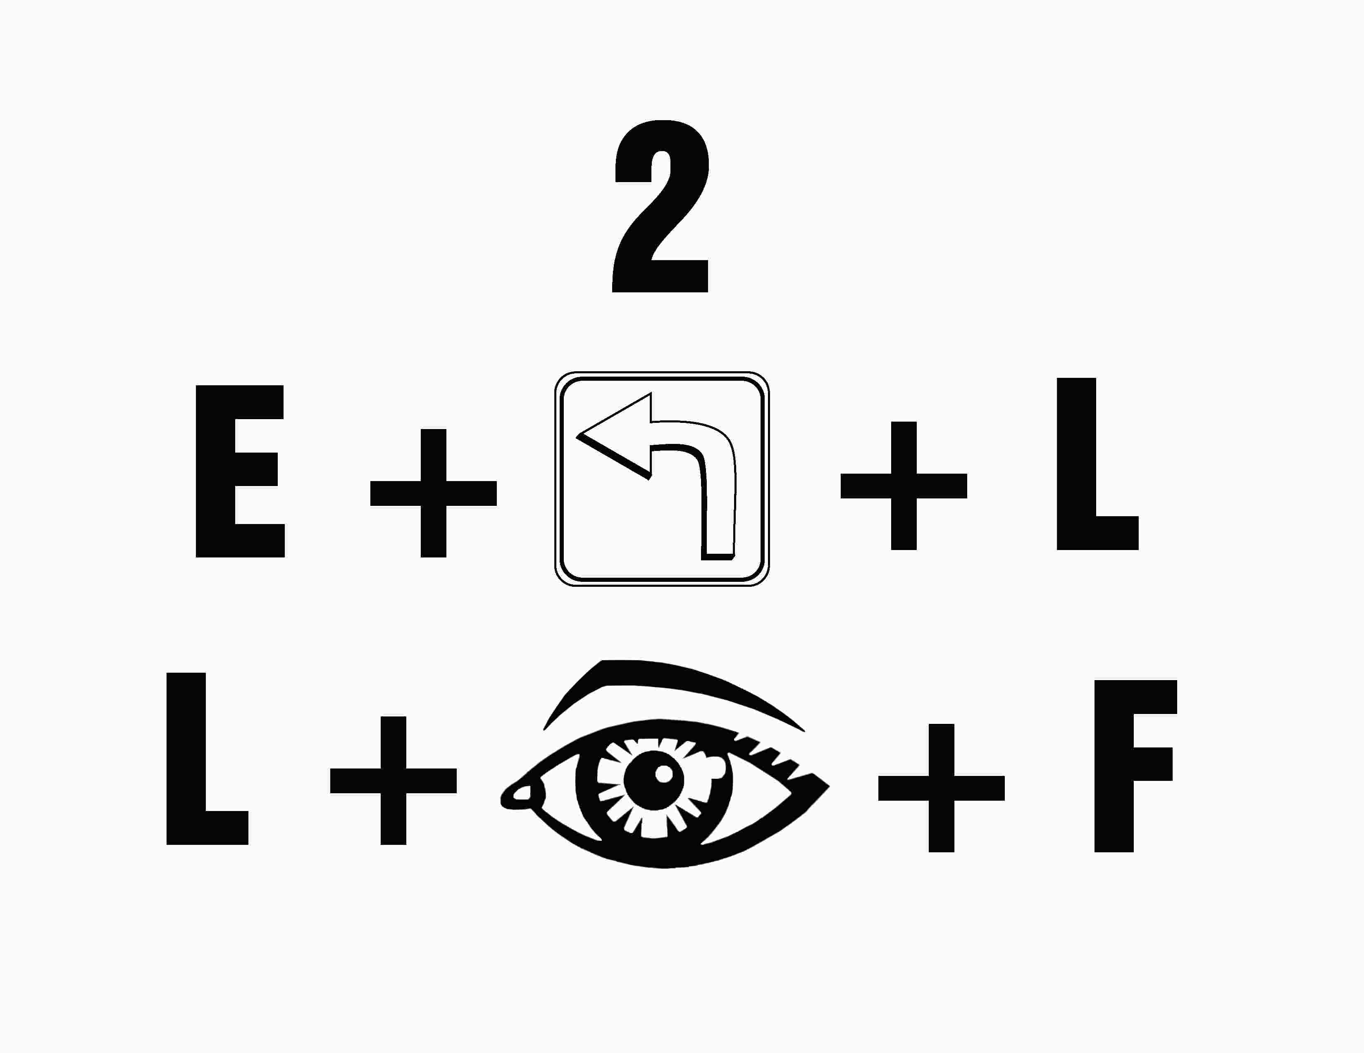

Appendix E

