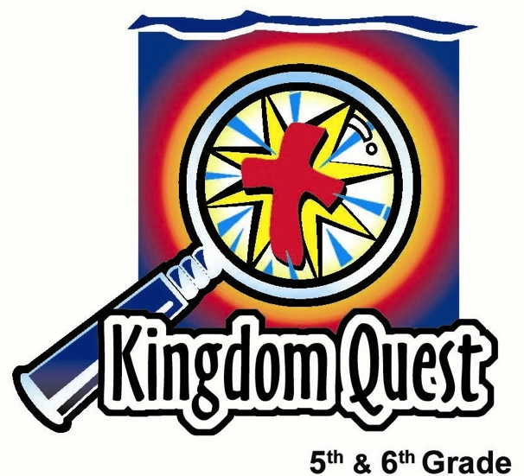
How Do We
Know the Bible is True?
Date: _________________________
Series: Sharpening Your Sword
(Dec-Feb) Year 2, Lesson 39

Take Home Point: The Bible is true—the evidence is convincing. *Repeat this phrase throughout the lesson.

Bible Event: 2 Peter 1:21
Key Verse: 2 Peter 1:21, “No prophecy ever came from what a person wanted to say, but people led by the Holy Spirit spoke words from God. “ (NCV)
.”

We will help kids know:
- The Bible can be proven to be historically accurate. Archaeological discoveries repeatedly confirm this.
- Prophecy confirms the Bible has supernatural origins. Mathematically, it is impossible for such a large number of prophecies to be fulfilled by chance.
- Miracles of Jesus substantiate His claim as the Messiah. These were seen by such a large number of people and recorded by different people that it is hard to debate their authenticity.
- The Bible tells the real life events from people, not glossing over their failures.
- The Bible explains God’s purpose for mankind: to have a relationship with Him. This is made possible through Christ.

We will help kids feel:
- Confident in the accuracy and reliability of the Bible.
- Awed by God’s purpose to give us His word.

We will help kids do:
  - Play a game of probability to understand that the accuracy of the Bible could not happen by chance.
  - Investigate biblical prophecies to see how they are fulfilled in Christ.

THIS LESSON’S ROADMAP

DESTINATION | PAGE # | DISCOVERIES ON YOUR JOURNEY | SUPPLIES NEEDED
  Small Group Warm-Up | 3 | Kids learn about probability by tossing coins and recording the number of times “heads” turn up. They discuss the probability of the prophecies of Jesus fulfilled, showing that the Bible is reliable and accurate. | - one penny for each student  - scratch paper and pencil for each student  - timer for leader
Large Group   | 5  7  8  13 | Overview  Challenge Game: Zaro, the Magnificent! challenges the students to recall all the books of the Bible.  The Bible Proves It Dart Game: Teams of students work together to pop balloons and answer questions regarding truth found in the Bible.  Appendices  NOTE: Further internet reference for biblical validity can be found at www.evidenceofgod.com | Costume:  - simple black cape and a black mask to resemble the Zoro character  Props:  - toy telescopic plastic lance  - newspaper roll sword for each small group  - five balloons with two questions (see Appendix A) each rolled up and placed inside the balloons before they are inflated, tied off and taped to a hard surface  - darts (Option: If no darts are available, tape straight pins to pencils, pens, or other item that could be thrown as a dart.)  - masking tape line on the floor  - labels for balloons: Archeology, Miracles, Real People, Prophecy, and Purpose
Small Group Application   | 5  8 | Kids look up Old Testament prophecies about Jesus and the corresponding fulfillment in the New Testament.  Memory Verse Learning:  “Verse-a-long”  2 Peter 1:21 will be repeated for lessons 38-41 to help children to learn to feel confidence in the accuracy and reliability of the Bible. | - Bibles  - Bible Prophecy sheets (see Appendix B) for each student  - a whistle  - two medium size items e.g. stuff toy animal or rubber ball  - 10 chairs
Small Group Warm-Up: 15 minutes
Purpose: Get pointed in the right direction! Build relationships and help guests feel at ease. Do the learning readiness activity that will point your group in the right direction for the lesson.

As kids gather: Listen to memory verses from last week and give coupons for memory verses, remembering to bring your Bible, and bringing a guest.

Supplies: one penny for each student, scratch paper and pencil for each student, timer for leader

Round One
Pass out paper and pencils. Have kids make two columns on the paper. Title one column “Number of tosses” and the other column “Heads.”

Explain that each kid gets to flip a coin as many times possible for 30 seconds. The objective is to see who can get heads the most number of times, keeping tally of how many times they flip the coin and the number of times the result shows heads. For example, after 30 seconds they might have flipped heads five out of ten times. (They can record this on their paper as 5:10.)

Pass out a penny to every student and say:

Okay, flippers, are your pennies ready? Get set… begin!

Time the students for 30 seconds and then stop everyone together. Note some of the answers and conclude that on the average, one out of every two times the coin is flipped, it will come up heads.

Round Two
For the next round, have kids find a partner. This time they flip their coins together and count how many times both coins come up heads. Have kids draw a line on their papers under Round One tally marks and say they must also count the total number of times the coins are flipped and how many times both coins turn up heads. This time let them flip for 60 seconds.

Okay, flippers, are your pennies ready? Get set… begin!

Compare answers. Point out that their answer should be about one out of four flips come up both heads. (Have them write the times both coins were heads: the number of tosses. For example, 1:4)

Round Three
Have kids get into groups of three and do the same thing, tossing three coins at a time. Record the number of tosses and the number of times all three coins turned up heads. Again, time this round for 60 seconds.

Okay, flippers, are your pennies ready? Get set… begin!

Stop the flipping after 60 seconds have passed and have the students record their answers. Point out that this number should average about one in eight flips coming up heads. (1:8)

Round Four
Have kids get into groups of four and tally how many times the coins all turn up heads at once within the 60-second time frame: the total number of times the coins were flipped. Adjust the size of the groups depending on the whole group size. For example, if you have seven kids, make a group of four and another group of three. If you have a group of nine kids, make one group of four and another group of five.

You will find that the average is one in 16 flips will have a group of four come up with all heads. (1:16)

Say:
How many times do you think we would have to flip for all the coins to turn up heads if we had eight of us flipping at the same time?

The chances are that in one out of 256 times, we would have all eight of us come up with heads. How many times do you think we’d have to flip if there were ten people trying? Probably1,024 times.

Commentary
We are dealing with probability today and we want to see how that relates to the Bible. What are the chances that God had nothing to do with the Bible’s actual writing? What are the chances that it was written by a group of people not inspired by God? Think about the prophets who wrote in the Old Testament about the promised Messiah. The chances that even eight of these promises to be fulfilled by one person, just by chance, are the same as if we did this:

Let’s say we lined up 56 people and asked them all to flip a coin at the same time. What would the chances be that on their first flip, all 56 came up with heads? The chances that would happen would be one in 72 quadrillion. Do you think it could ever happen? No? Well the chances are greater for that to happen than for eight prophecies about the Messiah to come true in one man simply by chance.

This is just one of the reasons that we can trust the Bible as God’s true word. Today we will discover that: *the Bible is true—the evidence is convincing.

Large Group Overview: 20-30 minutes
Purpose: Help kids observe what the Bible says. Present the Bible event in creative fashion. Help kids begin to interpret what it means.

Challenge Game: Zaro, the Magnificent! challenges the students to recall all the books of the Bible.

The Bible Proves It Dart Game: Teams of students work together to pop balloons and answer questions regarding truth found in the Bible.

Small Group Application: 20-25 minutes
Purpose: Help kids map out the meaning of the Bible event in their lives. Use the questions to stimulate discussion, but don't feel tied to them. Allow the Holy Spirit to guide you. Include personal examples from your own faith journey. The example of Christ at work in your life will leave lasting impressions of how Christ can work in the children's lives.

Use your Bibles! Children need to learn how to look up references and follow along when scripture is read aloud. Allow for quality time of prayer at the close of the lesson.

Observation Questions: What happened?/Interpretation Questions: What does this mean?
What evidence from large group convinced you the Bible is true?

Application Questions: What does this mean to me?
On a scale from one to ten, how convinced are you that the Bible is true?

What truth from the Bible gives you the most confidence? For example, one truth is that God created us. Another is that God sent His Son to die for us. Another is that God promises to be with all who trust Him. What truth gives you the most confidence and helps you feel peace in your heart?

Supplies: Bibles, Appendix B—Bible Prophecies for each student

Hand out the Bible Prophecy sheet and have each student choose one of the prophecies to look up both the Old and New Testament references. Have kids share their reading with the group and discuss how God used different authors to predict what would happen to the Messiah many years later.

Remember from Small Group Warm-Up how slim the chances are for one man to fulfill even eight prophecies? We are going to look at a few of the prophecies that Jesus fulfilled.

Then say:

In the magazine Science Speaks, Dr. Peter Stoner states that probability tells us that the chances of one out of eight predictions coming to pass, or being fulfilled in one person, is 1:100 quadrillion. That number is the same as the number of silver dollars it would take to spread over the state of Texas two feet deep.

The wonder of it all would occur when a blind man finds one marked silver dollar that had been hidden somewhere in that state and in that pile! That is the same chance as one of eight Old Testament prophecies coming true in any one man. Yet, we know that Jesus fulfilled more than 200 prophecies.

There are other historical writings that Jesus from Nazareth was a real person and was put to death on a cross. All of this, with the prophecies fulfilled through Jesus, give evidence of the reliability and accuracy of the Bible.

The key verse from 2 Peter 1:21 says, “No prophecy ever came from what a person wanted to say, but people led by the Holy Spirit spoke words from God.” The Bible is God’s holy word given to us and *it is true—the evidence is convincing.

Memory Verse Learning: 5 minutes
Purpose: Help kids to memorize and keep scriptures at heart. Using creative ways to help kids enjoy learning the key verse and in small group setting.

Supplies needed: a whistle, ten chairs, two medium size items e.g. stuff toy animal or rubber ball

Memory Verse: 2 Peter 1:21 ~ “No prophecy ever came from what a person wanted to say, but people led by the Holy Spirit spoke words from God.” (NCV)

MV Presentation: “Verse-a-long”
Before class, arrange the ten chairs in a circle. Have all the children recite the memory verse several times together. Select 10 children to play the game and have them seated on the chairs in a circle. Hand an item each to two children sitting opposite each other. At the signal of “Go”, both the children will pass the item to the person on their right. As everybody pass the items, they must recite the memory verse over and over again until you blow the whistle, then they must stop passing. Any two children having an item will be replaced by another two child of the class. Repeat the game as time permits.

Prayer:
Praise God for the prophecies that have come true in Jesus Christ. Thank Him that *the Bible is true—the evidence is convincing. Pray that the Holy Spirit would give us encouragement to spend daily time reading God’s word and that He would enlighten our minds to better understand it.
Safety and Security: Safety and security procedures are important for each church to carefully define and implement according to their unique needs. The security, safety, illness and accident procedures described in this curriculum are provided for example purposes only and may not be appropriate, applicable or adequate for every situation. Each church is responsible for determining whether any security, safety, illness and accident procedures contained in the curriculum are appropriate, applicable or adequate for its unique situation. The activities described in this curriculum require adult supervision and may not be suitable for each child and each situation. Each church is responsible for ensuring that adequate adult supervision is provided for all activities and for determining whether an activity is appropriate for each child and each situation. Kids Kount Publishing disclaims all liability for the implementation of any procedures or the performance of any activities described in this curriculum.

Large Group Presentation

The Bible is True
Costume:
- simple black cape and a black mask to resemble the Zoro character

Props:
- toy telescopic plastic lance that extends when flipped forward or possibly another option of a telescopic antenna rigged to a homemade sword handle (used for pointing out the key verses of the Bible)
- Bible as the sword tucked into presenter’s pocket or belt, like a sword in its sheath
- newspaper roll sword for each small group

Books of the Bible Challenge Game
Today, have kids recite all the books of the Bible.

Zaro, the Magnificent, enters in his costume and says:

For us to be able to use the sword and keep it sharp, we must be able to find our way through God’s word. That’s why it’s important to memorize the books of the Bible. You’ve been given that challenge already, so let’s see which group is worthy of the Bright Brainy Bible Book Award of Brilliance!

To earn this prestigious award, listen closely to the rules. Each group will have a newspaper sword as a baton. Once I say, “Books of the Bible experts, on your marks, get set, go!”, the first student begins. No student may say more than five books at a time before the baton is passed to a teammate. The teammate continues for as many books as he/she can remember but not more than five before passing it to the next team member. For any book that is recited in the wrong order or is left out, I will add an extra five seconds to the score. Shepherds, please listen carefully and count the number of mistakes made.

Give groups some time to discuss strategy and number themselves into an order for competing. Play the contest. If you have only two or three groups, have each group come up separately.

For churches with many groups, let the groups all begin reciting at the same time, having the shepherd judge if books are skipped or in the wrong order. Start with all groups standing. Have the groups sit down quietly as they finish. Tell them their time on the stopwatch. After all the groups are finished, have the shepherds report how many errors their groups had. Add five seconds for each error.

The Bible Proves It—Dart Game
Supplies: five balloons with two questions (See Appendix A,) each rolled up and placed inside the balloons before they are inflated, tied off and taped to a hard surface that won’t be damaged by the darts thrown at it, and darts (Option: If no darts are available, tape straight pins to pencils, pens, or other item that could be thrown as a dart.) Make a masking tape line on the floor.
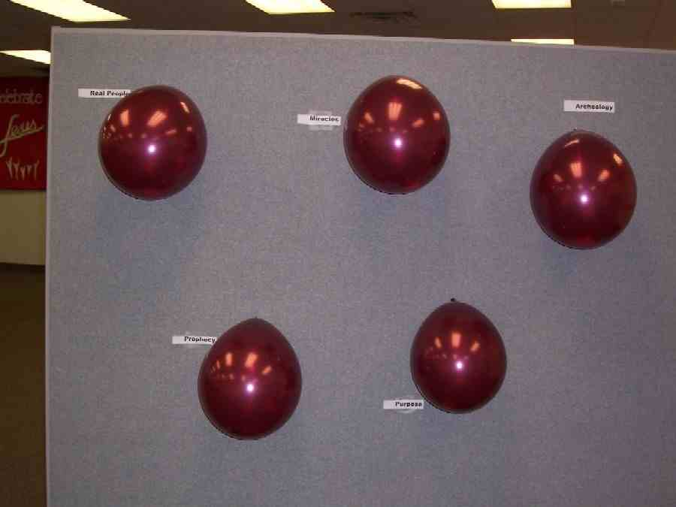

Once inflated, the balloons will be labeled according to the questions placed inside them. The labels could be printed on cards and taped near the balloons, or place the labels on the balloons themselves. The labels are “Archeology,” “Miracles,” “Real People,” “Prophecy,” and “Purpose.”

Two boys and two girls are invited forward to the throw line to play the game. The teams alternate (first the girls and then the boys) throwing darts until one hits a balloon. Whoever hits the balloon answers both of the enclosed questions. The answers should be obvious and clear.

Before any individual answers the questions, Zaro reads the brief introduction for that topic. If the boys are the first to pop a balloon, the girls are given a chance to pop the next balloon even if it takes repeated throws. After they have answered their question, the boys will shoot until they hit the next balloon. Since they are alternating, both teams will have popped two balloons each, leaving the fifth balloon. The first team to hit the fifth balloon will be the team to answer the questions and win the game.

*NOTE: the order may be different than the following, depending on the order the balloons are popped.

Archeology Introduction: (Read this before a student reads the archeology question.)

Zaro:
The Bible reports many historical facts. Some people say they could not be true. Archeology is the scientific study of remains of the past civilizations. This helps us understand the history and culture of people who lived in Bible times. Do these findings agree with the Bible’s account of history?

Kid reads and answers.

Question 1: Many scholars said that Daniel could not have written the book of Daniel at the time he said he wrote it. They said that he was wrong about the names of rulers and other facts of the Babylonian empire. What do you think archeologists later discovered?

- Daniel wasn’t a real person, but a storyteller who lived years later.
- Daniel was a real person and the names he used were later discovered to be the names used by the rulers of the time.
- Daniel was a bad speller and misspelled some of the rulers’ names of the day.

Question 2: Eighteen hundred years before Jesus, customs in Pharaoh’s court were written historically accurate from the Bible. These accounts of life in Egypt were described when the Bible talked about:
- King David
- Joseph
- Sinbad the sailor

Archeology Conclusion: (Read after both questions are answered.)

Zaro:
Archeology doesn’t prove that God wrote the Bible. But it does prove that the Bible is accurate in telling historical events.

Miracles:

Zaro:
When Jesus did Miracles, many people saw them. It was a small country and the word spread until soon throngs of people gathered. Could so many people be deceived? Or, was the Bible telling the truth about these miracles?

Kid:
Question 1: Jesus turned five loaves and two fish into enough food to feed some people. All these people not only saw a miracle, they were a part of it. There were more than:
- twelve people
- 600 people
- 5,000 people

Question 2: Even His enemies admitted He did miracles. It was just that they said He didn’t do them through the power of God. Instead, they said He did them through the power of:
- suggestion
- the devil
- psychic hotlines

Real People:

Zaro:
The Bible tells the real events of real people. If only someone making up a religion wrote the Bible, they probably would make the main characters better examples of good Christians. But, instead, the Bible tells of real life people with real life failures.

Kid:
Question 1: Peter was one of Jesus’ closest disciples and, yet, he denied Jesus:
- one time
- two times
- three times

Question 2: King David, one of the great heroes of the Old Testament, stole his captain’s wife and, then:
- traded her in for a new wife
- killed her husband
- tried to give her back

Prophecy:

Zaro:
Prophecies are predictions made about the future. Many different men of God in the Old Testament, called prophets, spoke hundreds of years before Jesus. They might have lived at different times and different places, yet, they all predicted aspects of Jesus and His life.

Kid:
Question 1: One of many prophecies about Jesus tells about the town He would be born in. It is:
- Jerusalem
- Bethlehem
- Manhattan

Question 2: Prophecy foretold that Jesus would be crucified with:
- some of His friends
- criminals
- three others

God’s Purpose:

Zaro:
The Bible gives us the message of who God is and what His purpose is for us. This doesn’t necessarily prove the Bible is true but it does state that its purpose is from God and not man.
Kid:
Question 1: God’s purpose for our lives is for us:
- to have a friendship with him forever
- to earn lots of money
- to watch more TV and play more Nintendo

Question 2: The Bible is the only book that tells how mankind’s relationship with God is fixed. That is not done by what people do to earn God’s favor but through:
- God giving Jesus as a sacrifice for our sins
- God giving us a new list of rules to follow so we can get it right
- Giving ten percent to the church

We have learned that the Bible is historically accurate because archeological facts agree with the Bible: many people witnessed Jesus’ miracles, the Bible describes real people, hundred of Old Testament prophecies were fulfilled in Jesus (not humanly possible), and the Bible communicates God’s purpose for us. God wants to have relationships with His people and will stop at nothing, even the death of His Son, for this to happen. Remember, *The Bible is true—the evidence is convincing.

Prayer:

Dear heavenly Father, we thank You for Your word that You give to show us Your purposes and how You want to have relationship with us. Thank You that Your word is accurate and reliable. We know that we can trust You and everything Your word says to us. Thank You for Your promise of salvation. Help us all to love Your word and to continue to grow through the study of it. Help us sharpen our swords so we are equipped to do battle for You. In Jesus’ name. Amen.

Lesson 39
Small Group Warm-Up
- one penny for each student
- scratch paper and pencil for each student
- timer for leader

Large Group
Costume:
- simple black cape and a black mask to resemble the Zoro character
Props:
- toy telescopic plastic lance
- newspaper roll sword for each small group
- five balloons with two questions (see Appendix A) each rolled up and placed inside the balloons before they are inflated, tied off and taped to a hard surface
- darts (Option: If no darts are available, tape straight pins to pencils, pens, or other item that could be thrown as a dart.)
- masking tape line on the floor
- labels for balloons: Archeology, Miracles, Real People, Prophecy, and Purpose

Small Group Application
- Bibles
- Bible Prophecy sheets (see Appendix B) for each student

Memory Verse Learning
- a whistle
- two medium size items e.g. stuff toy animal, rubber ball
- 10 chairs

Appendix A: Questions to be rolled up and placed inside of balloons.

Archeology balloon:

Question 1: Many scholars said that Daniel could not have written the book of Daniel at the time he said he wrote it. They said that he was wrong about the names of rulers and other facts of the Babylonian empire. What do you think archeologists later discovered?

  - Daniel wasn’t a real person, but a storyteller who lived years later.
  - Daniel was a real person and the names he used were later discovered to be the names used by the rulers of the time.
  - Daniel was a bad speller and misspelled some the rulers’ names of the day.
______________________________________________________________________

Question 2: Eighteen hundred years before Jesus, customs in Pharaoh’s court were written historically accurate from the Bible. These accounts of life in Egypt were described when the Bible talked about:
- King David
- Joseph
- Sinbad the sailor

Miracles balloon:

Question1: Jesus turned five loaves and two fish into enough food to feed some people. All these people not only saw a miracle, they were a part of it. There were more than:
- twelve people
- 600 people
- 5,000 people

Question 2: Even His enemies admitted He did miracles. It was just that they said he didn’t do them through the power of God. Instead, they said He did them through the power of:
- suggestion
- the devil
- psychic hotlines

Real People balloon:

Question 1: Peter was one of Jesus’ closest disciples and, yet, he denied Jesus:
- one time
- two times
- three times
______________________________________________________________________

Question 2: King David, one of the great heroes of the Old Testament, stole his captain’s wife and, then:
- traded her in for a new wife
- killed her husband
- tried to give her back

Prophecy balloon:

Question 1: One of many prophecies about Jesus tells about the town He would be born in. It is:
  - Jerusalem
b) Bethlehem
c) Manhattan

Question 2: Prophecy foretold that Jesus would be crucified with:
- some of His friends
- criminals
- three others

God’s Purpose balloon:

Question 1: God’s purpose for our lives is for us:
a) to have a friendship with him forever
  - to earn lots of money
  - to watch more TV and play more Nintendo
______________________________________________________________________

Question 2: The Bible is the only book that tells how mankind’s relationship with God is fixed. That is not done by what people do to earn God’s favor but through:
- God giving Jesus as a sacrifice for our sins
- God giving us a new list of rules to follow so we can get it right
- Giving ten percent to the church
Appendix B
Bible Prophecies Come True!
Prophecy Old Testament Reference New Testament Reference

Isaiah 7:14

Jeremiah 23:5

Micah 5:2

Zechariah 9:9

Psalm 41:9

Zechariah 11:12

Zechariah 11:13

Isaiah 53:7

Psalm 22:6-8

Isaiah 50:6

Isaiah 53:12

Isaiah 53:12b

Psalm 22:18

Psalm 22:16

Psalm 16:10
Matthew 1:18

Matthew 1:1

Luke 2:4-7/ Matthew 2:1

John 12:13-14

Mark 14:10

Matthew 26:15

Matthew 27:5,7

Matthew 26:60-63

Matthew 27:26, 39-40

Matthew 26:67 or Mark 14:65

Matthew 27:38

Luke 23:34

Mark 15:24

John 20:25,27

Matthew 28:9 or Luke 24:36-48
Jesus was to be born of a virgin

Jesus came from David’s royal family

Jesus to be born in Bethlehem

Jesus’ triumphal entry

Jesus betrayed by a friend

Betrayed with 30 pieces of silver

This money used to buy a potter’s field

Jesus remained silent when falsely accused

Jesus mistreated

Jesus spit on

Jesus crucified like a criminal

Jesus prayed for His
persecutors

People gamble for his clothes

Jesus’ hands and feet pierced

His resurrection

