Directions for Single Layer Fleece Prayer Blanket

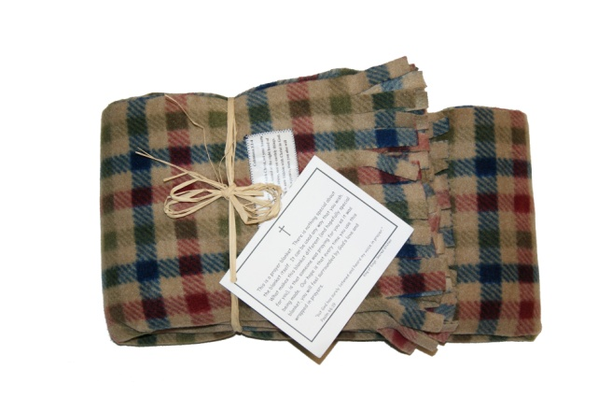
The most important aspect of this blanket is that the person who will receive the blanket is being prayed for as the blanket is being made!

Each blanket is made from 1 1/2 yards of 60 inch wide fleece fabric. It is best to use plaid fleece, as the plaid design makes cutting straight lines in the fabric much easier.

The two selvage ends of the fleece are trimmed off, and fringe is cut on these two sides. The fringe is about 3/4 inches wide and 2 inches long.

The other two (un-fringed) sides of the blanket are finished with a wide zigzag stitch on a sewing machine. It would also be fine not to finish these edges, as fleece does not fray.

The labels are made using Transformations, Design & Iron, Cotton Iron-On Transfer Sheets. Item #MPP16400. This can be found at craft stores such as Michaels or Hobby Lobby.

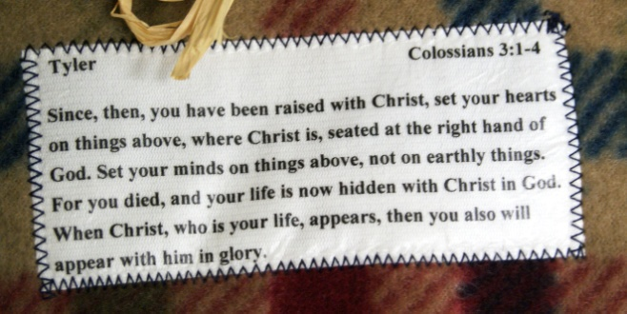
We include the student's first name, verse reference, and typed out verse on the label.

The labels are trimmed to size (several can be printed on a single transfer sheet), and ironed onto a corner of the blanket. The label is secured in place using a zigzag stitch on a sewing machine.

The blankets are folded, tied with raffia, and a Prayer Blanket card with the student's name is included.

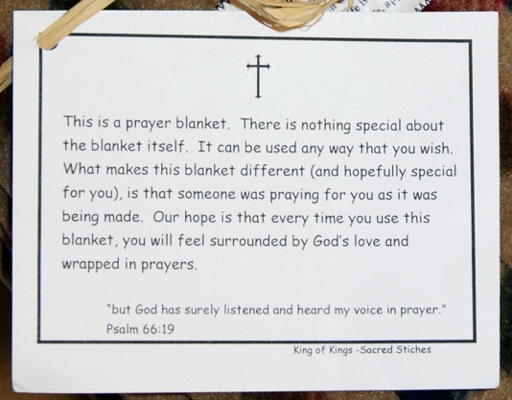
The prayer blanket card states:
This is a prayer blanket. There is nothing special about the blanket itself. It can be used any way that you wish. What makes this blanket different (and hopefully special for you), is that someone was praying for you as it was being made. Our hope is that every time you use this blanket, you will feel surrounded by God's love and wrapped in prayers.
"But God has surely listened and heard my voice in prayer." Psalm 66:19

